**SKILLSYNC - EMPOWER LEARNING TO CLOSE EDUCATIONAL GAPS USING CONVERSATIONAL AI**

*A project submitted in the partial fulfillment of the requirements for the*

*award of the degree of*

**BACHELOR OF TECHNOLOGY**

IN

**ARTIFICIAL INTELLIGENCE & DATA SCIENCE**

By

**N Jagadeesh - 21BQ1A5436**

**CH Raghavendra - 21BQ1A5408**

**V Raghavendra - 21BQ1A5455**

**E Hima Shankar Reddy - 21BQ1A5412**

Under the guidance of

**Dr. T. Sudhir**

**Professor**



#### Department of Artificial Intelligence & Data Science

**VASIREDDY VENKATADRI INSTITUTE OF TECHNOLOGY**

**(Autonomous)**

**Approved by AICTE, Permanently Affiliated to JNTUK, NAAC Accredited with‘A’ Grade, ISO 9001:2015 Certified**

Nambur (V), Pedakakani (M), Guntur (Dt.), Andhra Pradesh – 522 508

2024-25

**DECLARATION**

We, **Mr. Nalluri Jagadeesh, Mr. Chintakrindi Raghavendra, Mr. Vellaturi Raghavendra, Mr. Eguturi Hima Shankar Reddy** hereby declare that the Project Report entitled **“SKILLSYNC- EMPOWER LEARNING TO CLOSE EDUCATIONAL GAPS USING CONVERSATIONAL**

**AI”** done by us under the guidance of **Dr. T Sudhir, Professor** at Vasireddy Venkatadri Institute of Technology is submitted for partial fulfillment of the requirements for the award of Bachelor of Technology in Artificial Intelligence and Data Science. The results embodied in this report have not been submitted to any other University for the award of any degree.

DATE :

PLACE :

SIGNATURE OF THE CANDIDATE(S)

**(N. Jagadeesh) (Ch. Raghavendra) (V. Raghavendra)**

**(E. Hima Shankar Reddy)**



**CERTIFICATE**

This is to certify that this **Project Report** is the bonafide work of **Mr. Nalluri Jagadeesh, Mr. Chintakrindi Raghavendra, Mr. Vellaturi Raghavendra, Mr. Eguturi Hima Shankar Reddy** bearing Reg. No. **21BQ1A5436, 21BQ1A5408, 21BQ1A5455, 21BQ1A5412** respectively who had carried out the project entitled “**SKILLSYNC-EMPOWER LEARNING TO CLOSE EDUCATIONAL GAPS USING CONVERSATIONAL AI”** under our supervision.

**Project Guide**

Dr. T. Sudhir, Professor

**Head of Department**

Dr. T. Sudhir, Professor

**Submitted for Viva voce Examination held on**

**Internal Examiner External Examiner**

**ACKNOWLEDGEMENT**

We take this opportunity to express my deepest gratitude and appreciation to all those people who made this project work easier with words of encouragement, motivation, discipline, and faith by offering different places to look to expand my ideas and helped me towards the successful completion of this project work.

First and foremost, We express my deep gratitude to **Mr. Vasireddy Vidya Sagar garu**, Chairman, Vasireddy Venkatadri Institute of Technology for providing necessary facilities throughout the B. Tech programme.

We express my sincere thanks to **Dr. Y. Mallikarjuna Reddy**, Principal, Vasireddy Venkatadri Institute of Technology for his constant support and cooperation throughout the B. Tech programme.

We express my sincere gratitude to **Dr. T. Sudhir**, Professor & HOD, Artificial Intelligence and Data Science, Vasireddy Venkatadri Institute of Technology for his constant encouragement, motivation, and faith by offering different places to look to expand my ideas.

We would like to express my sincere gratefulness to our Guide, **Dr. T. Sudhir**, Professor for his insightful advice, motivating suggestions, invaluable guidance, help and support in successful completion of this project.

We would like to take this opportunity to express my thanks to the **Teaching and Non- Teaching** Staff in the Department of Artificial Intelligence and Data Science, VVIT for their invaluable help and support.

**N. Jagadeesh CH. Raghavendra**

**V. Raghavendra**

**E. Hima Shankar Reddy**

**TABLE OF CONTENTS**

|  |  |
| --- | --- |
| **Description**  List of Figures | **Page No**  iii |
| **Chapter – 1 : Introduction**   * 1. Problem statement   2. Objectives   3. Scope of the project   4. Significance of conversational AI in Education | 1  2  4  5 |
| **Chapter – 2 : Literature Review**   * 1. Existing Learning platform and their gaps   2. Role of AI in Personalized Education   3. Conversational AI for Student Engagement   4. Case studies on AI Driven Learning | 7  9  10  11 |
| **Chapter – 3 : System Architecture & Design**   * 1. Overview of skillsync platform   2. AI driven chatbot workflow   3. Machine Learning and NLP models used   4. Frontend and Backend Technologies   5. Security and Scalability considerations | 13  14  15  15  16 |
| **Chapter – 4 : Implementation and Features**   * 1. Conversational AI model training   2. Student-Teacher Interaction Module   3. Personalized Learning Paths   4. Dashboard and Analyics Integration | 17  18  19  19 |
| **Chapter – 5 : Testing and Performance Evaluation**   * 1. Testcases and Methodologies   2. Accuracy and response time analysis   3. User feedback and adaptations   4. AI model fine-tuning and updates   **Chapter – 6 : Conclusion and Future Scope**   * 1. Summary and Findings   2. Limitations of Current system   3. Teacher Efficiency and Interaction analysis   4. Scalability and Future Enhancements   5. Conclusion and Future Scope   6. Appendices | 22  23  24  26  28  29  31  35  40  42 |

|  |  |
| --- | --- |
| **Bibliography APPENDIX**  **Conference Presentation Certificate**  **Published Article in the Journal** | 45  46  51 |

**List Of Figures**

|  |  |  |
| --- | --- | --- |
| **S.No** | **Figure Name** | **Page.No** |
| 1.3(a) | Objective of skillsync | 3 |
| 2.1(a) | Flow Diagram of Existing Learning platform | 8 |
| 2.3(a) | Conversational AI for student Engage | 10 |
| 2.4(a) | Use case Diagram | 12 |
| 3  3.5(a)  3.5(b)  5.2.1  5.4.2  6.1 | Skillsync System Architecture  Sequence Diagram Class Diagram  Accuracy and Response-Time User Feedback  AI Model Fine Tuning Conclusion | 13  16  16  23  29  30 |

iii

#### Nomenclature

|  |  |
| --- | --- |
| HTML – | HyperText Markup Language for structuring web pages. |
| CSS – | Cascading Style Sheets for designing and styling web pages. |
| JS – | JavaScript, a scripting language for frontend interactivity. |
| Node.js – | A JavaScript runtime used for backend development. |
| Flask – | A lightweight Python web framework for backend services. |
| MySQL – | A relational database for storing student and faculty data. |
| Chatbot – | An AI-powered conversational assistant for student queries. |
| Localhost – | The deployment environment for testing and running the application locally. |
| Dashboard – | A UI module displaying performance analytics and insights |

**ABSTRACT**

In modern educational ecosystems, bridging learning gaps and aligning student skills are essential for fostering equitable and effective learning. SkillSync is an innovative platform designed to leverage analytics to eliminate educational disparities. Through its centralized system, students can participate in personalized tests, ask questions, and engage in real-time interactions with faculty. The platform features an intuitive dashboard that provides analytical visualizations powered by data modelling, alongside insights into queries and faculty responses. Additionally, the integrated testing module evaluates student performance, with results displayed on the dashboard to deliver transparent feedback and track progress effectively. By streamlining query management and performance analysis, SkillSync equips students with the tools to address their learning gaps successfully. Simultaneously, it supports educators in monitoring progress and optimizing teaching strategies, fostering a collaborative and data- driven educational environment.

# CHAPTER-I

### INTRODUCTION

###### INTRODUCTION:

Education is the foundation of progress, but traditional teaching methods often fail to cater to the diverse learning needs of students. In many cases, students hesitate to ask questions due to fear of judgment, while others struggle with the fast-paced curriculum. Teachers, on the other hand, find it challenging to track the individual learning progress of every student in a classroom setting. These gaps lead to disengagement, lack of clarity, and poor academic performance.

SkillSync aims to address these challenges by using Conversational AI, an advanced artificial intelligence system capable of interacting with students in real time. Unlike conventional e- learning platforms, which primarily rely on recorded lectures and static materials, SkillSync will provide interactive and adaptive learning support. This ensures that students receive instant feedback, personalized learning resources**,** and a structured path to overcome academic weaknesses.

Additionally, the platform assists teachers by providing insights into student engagement, performance trends, and areas of difficulty. This allows educators to modify their teaching strategies for better outcomes, making SkillSync a comprehensive solution to bridge educational gaps.

SkillSync aims to bridge the educational gaps between students and teachers by integrating Conversational AI into the learning process. The platform will function as a 24/7 virtual assistant, guiding students through personalized learning paths, resolving doubts in real time, and providing immediate performance analytics to educators. By leveraging AI, SkillSync will empower students to take control of their learning journey while assisting teachers in delivering more effective education.

In summary, the traditional education system lacks the flexibility, personalization, and real-time engagement required for optimal learning experiences. The SkillSync platform seeks to close these gaps by using AI-driven solutions, ensuring that students receive instant support, personalized study plans, and interactive learning experiences that align with their unique needs.

SkillSync aims to address the challenges faced by students in traditional e-learning environments by leveraging Conversational AI, an advanced artificial intelligence system capable of interacting with students in real time. Unlike conventional e- learning platforms, which primarily rely on recorded lectures and static materials, SkillSync offers a dynamic and interactive learning experience. This ensures that students receive instant feedback, personalized learning resources, and a structured path to overcome academic weaknesses.

###### OBJECTIVES

1. Develop an AI-powered chatbot that assists students in understanding complex concepts across various subjects.
2. Enable 24/7 learning support, allowing students to seek help anytime, anywhere. 3.
3. Provide personalized learning paths using AI-driven analytics, ensuring that students receive targeted content based on their strengths and weaknesses.
4. Help teachers track student progress with automated performance reports and visual insights.
5. Ensure scalability and security, making the platform accessible across multiple institutions and adaptable for various curriculums.

The primary objective of SkillSync is to enhance the learning experience through AI- powered conversational support, enabling students to bridge their knowledge gaps effectively. The platform is designed to offer a personalized, interactive, and data- driven educational experience that benefits both students and teachers. By leveraging advanced AI models, real-time analytics, and intelligent tutoring, SkillSync will redefine the way education is delivered and consumed.

One of the key goals of SkillSync is to facilitate real-time student-teacher interactions through AI-driven chatbots. Many students hesitate to seek help in a traditional classroom environment due to social anxieties or fear of judgment. The AI assistant within SkillSync will allow students to ask questions freely, receive instant responses, and engage with subject-specific AI tutors, making the learning process more approachable and stress-free.

Another major objective is to enable 24/7 access to personalized learning resources. Unlike conventional classrooms that function within fixed schedules, SkillSync will provide uninterrupted educational support, ensuring that students can learn at their own pace. Whether it is solving a difficult math problem at midnight or revising complex scientific concepts early in the morning, students will have on-demand assistance at their fingertips.

One of the key features of SkillSync is its ability to provide interactive learning support. Through real-time conversations, students can ask questions, seek clarifications, and engage in discussions that mimic the experience of having a personal tutor. This interactive approach helps to keep students engaged and motivated, as they can receive immediate responses to their queries and feel good.

Finally, SkillSync will ensure scalability and security, making it accessible to educational institutions of all sizes. Whether it’s a single classroom or a nationwide digital education initiative, the platform will be designed for seamless integration with existing learning management systems (LMS) and educational technologies. Security measures will also be in place to safeguard student data, ensuring privacy and compliance with educational standards.

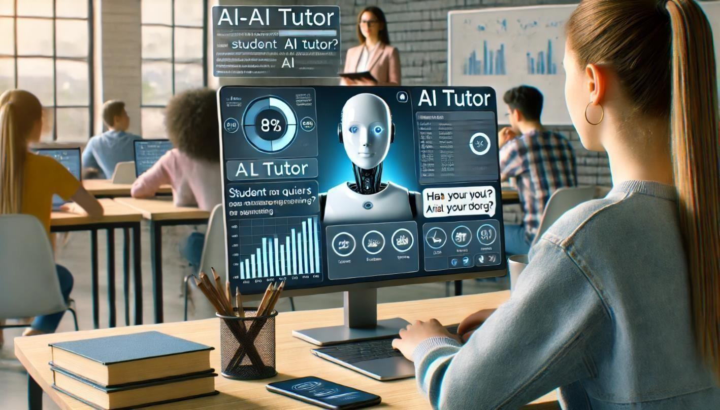

Fig 1.2(a) : Objective of SkillSync

By achieving these objectives, SkillSync will create a transformative educational ecosystem where students receive unlimited AI-powered support, teachers gain valuable insights, and learning becomes a more engaging, personalized, and inclusive process.

SkillSync's Conversational AI is designed to adapt to the individual needs of each student. By analyzing their performance, learning style, and areas of difficulty, the AI can tailor the learning resources to suit their specific requirements. This personalized approach ensures that students are not overwhelmed by generic content but are instead provided with materials that are relevant and beneficial to their academic growth.

###### 1.3. SCOPE OF THE PROJECT

SkillSync is designed to serve students, teachers, and educational institutions across different levels of learning. The platform can be deployed in:

* Schools and Universities: To provide AI-assisted learning for students struggling
* With concepts in subjects like Mathematics, Science, and Languages.
* Online Learning Platforms: To enhance traditional e-learning by offering interactive
* AI-driven engagement instead of static recorded lectures.
* Corporate Training Programs: To assist employees in skill development through
* AI-driven courses and assessments.

The SkillSync platform is designed to bridge the learning gap between students and teachers by providing an AI-powered educational assistant. This system is not limited to just one educational domain—it is scalable and adaptable for various learning environments, including schools, universities, corporate training programs, and online learning platforms.

Its integration with Conversational AI, Natural Language Processing (NLP), and machine learning ensures that students receive instant support while teachers can track and optimize learning outcomes

One of the primary areas where SkillSync will have an impact is in formal education settings, such as schools and universities. Traditional education follows a structured approach, where all students are expected to grasp concepts at the same pace. However, students have different learning speeds, strengths, and weaknesses, making it difficult for educators to provide equal attention to everyone. SkillSync will personalize learning paths for each student based on their individual progress, allowing them to revisit complex topics, practice additional exercises, and ask

AI-powered tutors for clarification at any time. This feature is particularly beneficial for students preparing for competitive exams, as it will allow self-paced learning with real-time feedback.

One of the major drawbacks of traditional e-learning platforms is the lack of immediate feedback. SkillSync addresses this issue by offering instant feedback on assignments, quizzes, and other learning activities. This timely feedback helps students to understand their mistakes, learn from them, and improve their performance. It also allows them to track their progress and stay motivatedthroughout.

###### 1.4 SIGNIFICANCE OF CONVERSATIONAL AI IN EDUCATION

The integration of Conversational AI in education is a revolutionary step towards making learning more interactive, personalized, and accessible. Unlike traditional teaching methods, which rely on fixed schedules, static content, and human- dependent instruction, Conversational AI enables real-time, intelligent, and data- driven educational experiences. It provides instant doubt resolution, customized learning paths, and automated assessment tools, allowing students to learn at their own pace without feeling left behind.

One of the biggest advantages of Conversational AI is its ability to offer 24/7 academic assistance. In traditional classrooms, students often have to wait until the next school day or an available tutoring session to get their doubts cleared. However, learning difficulties can arise at any time, and waiting for an answer can lead to frustration and disengagement. Conversational AI eliminates this delay by providing instant responses to queries, ensuring continuous learning without interruptions.

Furthermore, Conversational AI brings a personalized approach to education. Every student has different strengths and weaknesses, and a fixed curriculum does not always accommodate individual learning needs. AI-powered tutors can analyze student performance in real-time and suggest customized exercises, revision materials, or additional resources based on the student's progress. For instance, if a student struggles with a particular math problem, the AI assistant can break down the solution step by step, provide relevant examples, and offer practice problems tailored to that student's difficulty level.

Additionally, Conversational AI significantly enhances student engagement. Traditional lectures and recorded video lessons often lack interactivity, making students passive learners rather than active participants. AI-driven learning platforms can introduce interactive quizzes, gamification elements, and real-time challenges that make learning more dynamic and stimulating. By transforming education into an interactive dialogue rather than a one-way information delivery system, AI fosters better retention and understanding of concepts.

SkillSync provides a structured path for students to overcome their academic weaknesses. By identifying areas where students struggle, the AI can create a customized learning plan that focuses on these specific challenges. This targeted approach helps students to build a strong foundation in subjects they find difficult and gradually improve their overall academic performance.

**CHAPTER 1 INTRODUCTION**

Conversational AI also plays a crucial role in teacher support and classroom management. Educators often spend a considerable amount of time grading assignments, tracking student performance, and managing administrative tasks. AI- powered teaching assistants can automate these tasks, generate performance reports, and highlight key insights on student progress, allowing teachers to focus more on personalized mentoring and creative teaching methods. This ensures that teachers can spend more time addressing complex topics and guiding students effectively.

Finally, the implementation of Conversational AI in education is a step towards the future of smart learning environments. With advancements in machine learning, natural language processing, and AI-powered adaptive systems, education will no longer be limited to fixed structures The future classroom will integrate AI tutors, immersive learning technologies (such as virtual reality and augmented reality), and AI-driven collaboration tools, ensuring that students receive a fully interactive, engaging , and tailored learning experience.

The interactive and adaptive nature of SkillSync enhances student engagement. Traditional e- learning platforms often struggle to maintain student interest, leading to high dropout rates. SkillSync's real-time interactions and personalized content keep students engaged and motivated, reducing the likelihood of disengagement and dropout.

# CHAPTER-II

### LITERATURE REVIEW

###### EXISTING LEARNING PLATFORMS AND THEIR GAPS

Over the past decade, the rise of digital learning platforms has transformed education, making it more accessible and flexible. Platforms such as Coursera, Udemy, edX, and Khan Academy have gained widespread popularity by offering structured courses, video lectures, and certification programs. However, despite their benefits, these platforms suffer from significant limitations that hinder their effectiveness in bridging the learning gap between students and educators.

One of the biggest challenges of existing e-learning platforms is their lack of real-time interaction and doubt resolution mechanisms. Most platforms rely on pre-recorded lectures and static content, which means students have no way of asking questions instantly when they struggle with a concept. Some platforms provide discussion forums, but responses are often delayed, and many queries remain unanswered. This absence of instant, personalized feedback discourages active engagement and can lead to frustration, confusion, and reduced learning efficiency.

Another major gap in traditional e-learning systems is the lack of personalized learning paths. Every student learns at a different pace, with unique strengths and weaknesses. However, most online platforms follow a standardized approach, delivering the same content to all students, regardless of their individual progress. A student struggling with a specific topic may need extra practice exercises, alternative explanations, or interactive simulations, but existing platforms rarely provide such adaptive learning experiences. As a result, students either lose interest or fail to grasp key concepts effectively.

Additionally, student engagement is a persistent challenge in digital learning. Self- paced courses require high levels of motivation and discipline, but without a human- like interaction mechanism, many students find it difficult to stay focused. Studies show that online course completion rates are significantly lower than traditional in-person classes, primarily due to a lack of interactive engagement. Passive learning through videos and static quizzes does not encourage active participation, which is essential for deep understanding.

SkillSync is designed to be accessible and convenient for students. The platform can be accessed from any device with an internet connection, allowing students to learn at their own pace and from any location. This flexibility is particularly beneficial for students with busy schedules or those who prefer to learn outside of traditional classroom settings.

|  |  |
| --- | --- |
| Real-time | + Not ■✓ AI Chatbots for Instant |
| Interaction | Available Response |
| Personalized | + Standardized for ■✓Tailored Learning |
| Learning | All Paths |
| Engagement |  |
|  | + Passive ■✓ Interactive Quizzes & AI |
| & |  |
|  | Learning Tutors |
| Motivation |  |
| Teacher | + Limited ■✓ AI-driven Student |
| Support | Analytics Insights |

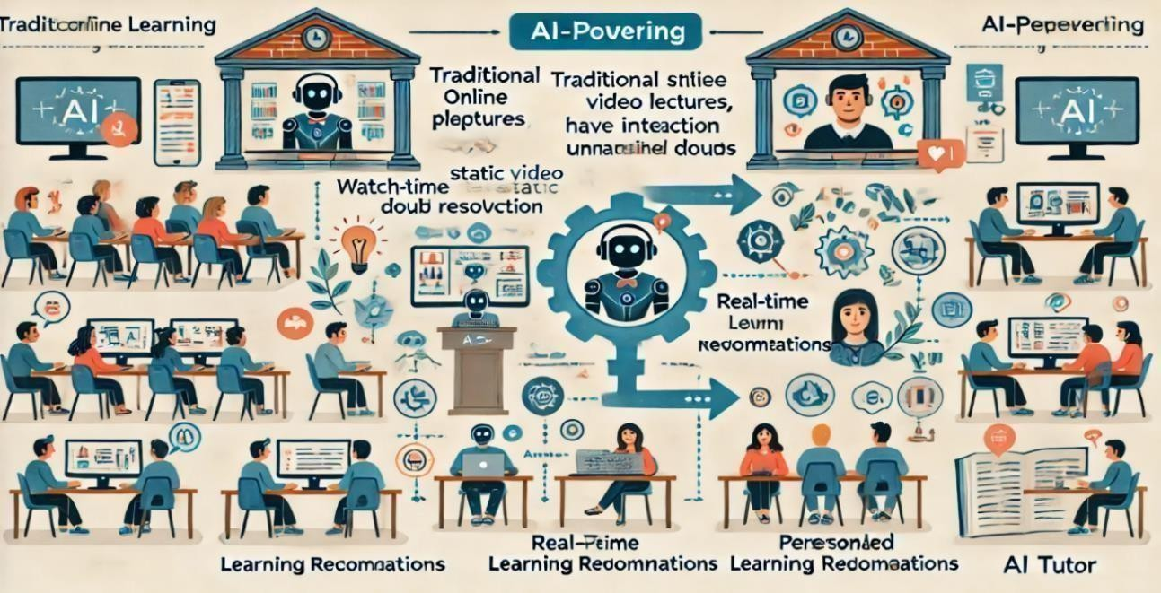

Fig 2.1(a) : Flow Diagram of Existing Learning platforms

SkillSync recognizes that students have diverse learning styles and preferences. The Conversational AI can adapt its teaching methods to suit visual, auditory, and kinesthetic learners. By providing a variety of learning resources, such as videos, audio clips, and interactive exercises, SkillSync ensures that all students can benefit from the platform, regardless of their preferred learning style.

###### ROLE OF AI IN PERSONALIZED EDUCATION

Artificial Intelligence (AI) is revolutionizing education by making learning more personalized, interactive, and adaptive. Unlike traditional educational models that follow a one-size-fits-all approach, AI-driven systems can analyze individual student performance, track learning patterns, and recommend customized study materials based on real-time data. This ensures that each student receives tailored support, leading to higher engagement, better retention, and improved academic performance.

One of the key advantages of AI in education is its ability to identify student weaknesses and suggest targeted improvements. For example, if a student struggles with algebra but excels in geometry, an AI-driven system can prioritize algebra-based exercises while offering advanced geometry challenges to keep them engaged. This customized approach prevents students from feeling overwhelmed or disengaged, allowing them to progress at their own pace.

AI also enhances learning by automating assessments and feedback mechanisms. Traditional testing methods, such as quizzes and exams, provide delayed feedback, making it difficult for students to correct mistakes immediately. With AI-powered assessments, students receive instant feedback on their performance, along with step- by-step explanations for incorrect answers. This real-time correction process helps reinforce learning and ensures that students can identify and improve weak areas.

**Types of AI in Personalized Learning**

1. **Adaptive Learning AI** – Adjusts difficulty level based on student progress
2. **Natural Language Processing (NLP)** – Understands and responds to student queries
3. **AI-based Analytics** – Tracks student performance for educators
4. **Chatbots & Virtual Tutors** – Offer real-time doubt resolution
5. **Automated Assessments** – Provide instant feedback and grading

SkillSync is committed to continuous improvement. The AI system is designed to learn and evolve based on student interactions and feedback. This ongoing development ensures that the platform remains effective and relevant, providing students with the best possible learning experience.

SkillSync also fosters collaboration and community building among students. The platform includes features that allow students to connect with peers, participate in group discussions, and work on collaborative projects. This sense of community helps to create a supportive learning environment where students can share knowledge, exchange ideas, and learn from each other.

###### CONVERSATIONAL AI FOR STUDENT ENGAGEMENT

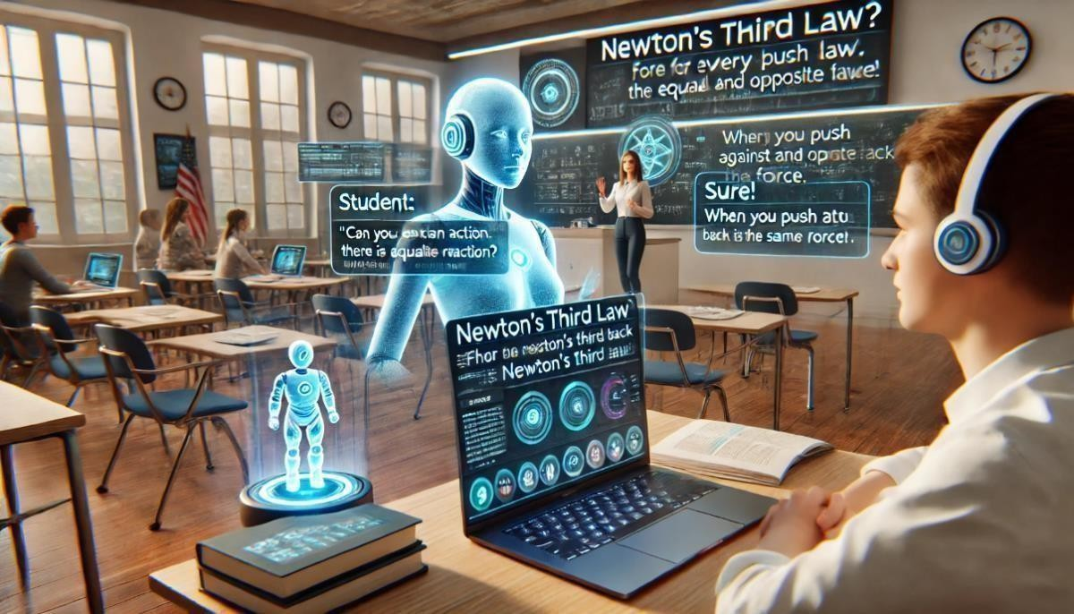

Fig 2.3(a) : Conversational AI for student engage

One of the biggest challenges in education is keeping students actively engaged throughout the learning process. Traditional methods, whether classroom-based or online, often lack interactivity, leading to low participation and poor retention of information. Conversational AI solves this problem by introducing interactive, real- time discussions that make learning more engaging, dynamic, and effective.

Conversational AI can act as an interactive tutor, allowing students to ask questions at any time and receive immediate, context-aware responses. Unlike pre-recorded lessons or static textbooks, AI-powered chatbots provide instant explanations, additional examples, and alternative solutions to help students understand complex topics better. This two-way communication ensures that students remain actively involved in the learning process, rather than passively consuming information.

Another major advantage of Conversational AI is its ability to gamify the learning experience. By incorporating quizzes, interactive challenges, and rewards, AI-powered platforms encourage students to participate more frequently and stay motivated. Gamification has been proven to increase retention rates and improve student performance by making learning feel less like a chore and more like an enjoyable activity. Conversational AI also provides real-time adaptive feedback, ensuring that students receive instant clarification on mistakes. .

###### CASE STUDIES ON AI DRIVEN LEARNING MODELS

**Case Study 1: Duolingo – AI for Language Learning**

Duolingo is a language-learning platform that leverages AI-driven personalization to tailor learning experiences for users worldwide. With over 500 million users, Duolingo provides interactive lessons based on Natural Language Processing (NLP), machine learning, and gamification techniques.

AI Implementation

Personalized Learning Paths: AI adapts lesson difficulty based on user performance Gamification & Engagement: AI tracks user behavior and progress, offering rewards and challenges to boost motivation.

Results & Impact

Increased student engagement with a 34% rise in daily practice sessions. Improved language proficiency through adaptive difficulty levels. Higher retention rates compared to traditional language courses.

**Case Study 2: Carnegie Learning – AI-Powered Math Tutoring**

Carnegie Learning is an AI-driven mathematics learning platform that provides adaptive learning experiences to students. The system uses cognitive science and AI algorithms to help students master mathematical concepts through step-by-step problem-solving guidance.

AI Implementation

MATHia AI Tutor: Tracks individual student progress and adjusts lesson plans dynamically.

As technology continues to advance, SkillSync will be able to offer even more sophisticated and effective learning solutions, helping students to achieve their academic goals and succeed in their educational pursuits.

By combining the power of Conversational AI with personalized learning, the platform can address many of the limitations of traditional e-learning methods.

Predictive Analytics: Identifies students at risk of falling behind and recommends early interventions.

Real-Time Feedback: AI provides instant corrections and explanations for incorrect answers.

Results & Impact

30% increase in student problem-solving accuracy.

Enhanced teacher support through AI-generated performance reports. Significant improvement in mathematical reasoning skills.

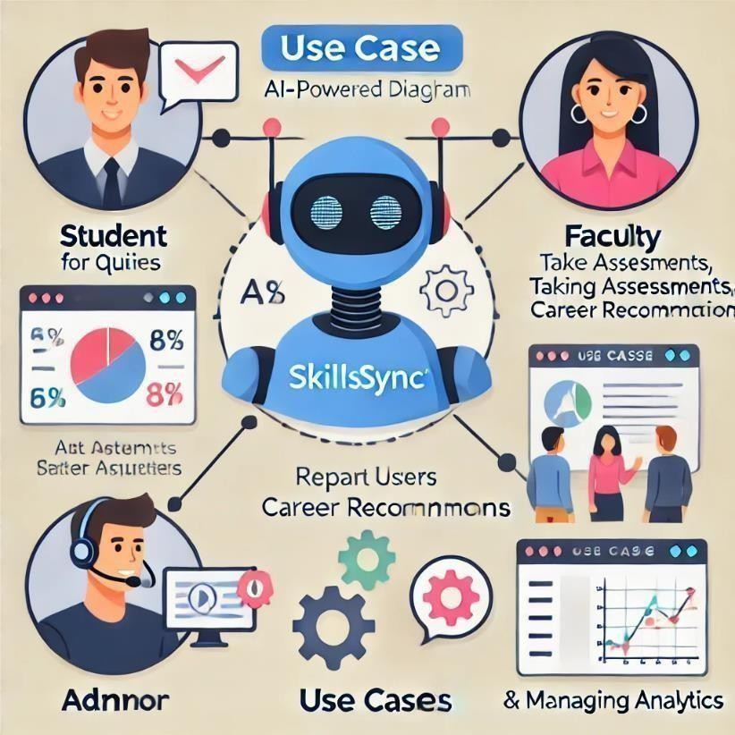

Fig: 2.4(a) : Use Case Diagram

# CHAPTER-III

## SYSTEM ARCHITECTURE & DESIGN

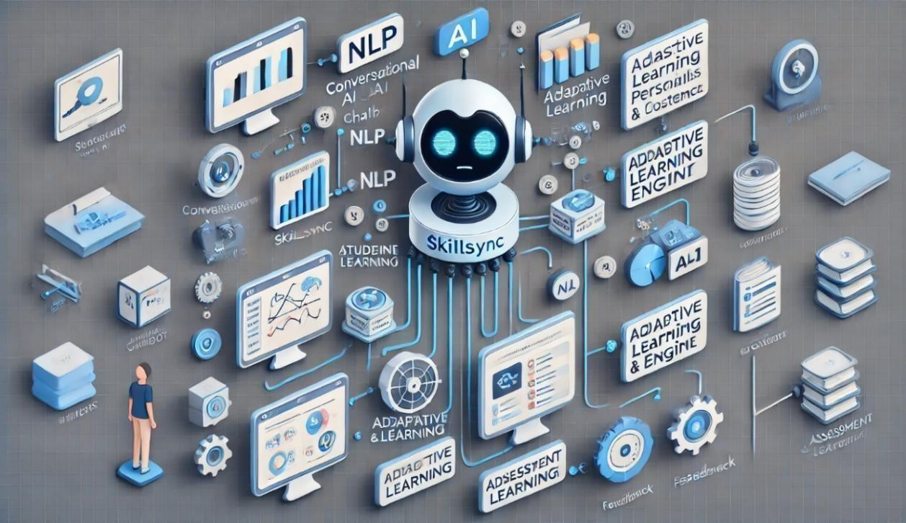

Fig 3: SkillSync System Architecture

The architecture of SkillSync is designed to facilitate seamless interaction between students and AI-driven learning modules while providing real-time insights to educators. The system comprises multiple components, including the conversational AI chatbot, adaptive learning engine, analytics dashboard, and assessment management module. Each of these components plays a crucial role in enhancing personalized learning experiences and improving student engagement. The platform's backend is structured to handle a high volume of queries while ensuring quick and accurate responses through natural language processing (NLP) techniques.

###### 3.1.OVERVIEW OF SKILLSYNC PLATFORM

The SkillSync platform is built as a multi-layered AI-driven learning system designed to provide personalized education, real-time student support, and teacher-assisted monitoring. The architecture ensures seamless interaction between students and AI modules, with integrated analytics for tracking performance. By leveraging natural language processing (NLP), adaptive learning algorithms, and cloud-based infrastructure, the platform aims to bridge the educational gap between students and teachers. SkillSync is designed to seamlessly integrate with existing educational systems and platforms. This compatibility ensures that schools, colleges, and universities can adopt SkillSync without disrupting their current operations. The platform can be customized to align with specific curricula, assessment methods, and educational standards, making it a versatile tool for educators.

At the core of SkillSync is the Conversational AI Chatbot, which allows students to ask questions, receive instant responses, and get AI-driven learning recommendations. The Adaptive Learning Engine continuously monitors student progress, ensuring dynamic content adjustments based on individual learning needs. In parallel, the Analytics Dashboard provides insightful reports to educators, highlighting key areas where students may need additional guidance.

Security and scalability play a crucial role in the system architecture. By utilizing cloud- based storage and encryption protocols, SkillSync ensures data privacy and seamless access across multiple devices. The system is scalable, meaning it can be deployed in schools, universities, and online learning environments without compromising performance.

###### AI-DRIVEN CHATBOT WORKFLOW

The Conversational AI Chatbot is designed to provide instant academic support to students while reducing the burden on teachers. The chatbot functions through three main AI models:

1. Natural Language Processing (NLP) Model – Understands student queries and processes text-based interactions.
2. Machine Learning-Based Response Engine – Matches questions with relevant answers, improving over time.
3. Deep Learning Context Analyzer – Identifies complex queries and offers multi-step solutions with explanations

**Workflow of the AI Chatbot**

1. Student submits a query (e.g., "Explain Newton’s Third Law").
2. NLP model interprets the question and extracts relevant keywords.
3. Machine learning engine retrieves the best answer from the knowledge database.
4. Response is generated and displayed to the student.
5. AI tracks student interactions and updates learning preferences over time.

###### MACHINE LEARNING & NLP MODELS USED

The AI-powered chatbot and adaptive learning modules are based on advanced machine learning (ML) and natural language processing (NLP) techniques. These technologies allow SkillSync to analyze student input, learning behavior, and engagement trends.

|  |  |
| --- | --- |
| **AI MODEL** | **FUNCTION** |
| Natural Language rocessing(NLP) | Understands and interprets student queries |
| Machine Learning Recommendation System | Suggests personalized study materials |
| Sentiment Analysis Model | Identifies student frustration or confusion |
| Predictive Analytics Model | Forecasts student performance based on learning patterns |

###### FRONTEND AND BACKEND TECHNOLOGIES

The SkillSync platform is developed using a modern tech stack to ensure high-speed performance, scalability, and security.

The system is divided into:

1. **Frontend Technologies** – **Handles user interactions and UI components**.
2. **Backend Technologies – Manages AI models, databases, and cloud-based processing.**

|  |  |
| --- | --- |
| **Component** | **Technology Used** |
| Frontend | Html, css, Javascript |
| Backend | Flask |
| Database | MySQL |
| AI Frameworks | OpenAI GPT |

###### SECURITY AND SCALABILITY CONSIDERATIONS

To ensure data privacy and scalability, SkillSync implements robust security protocols cloud- based architecture.

Key Security Measures in SkillSync

* + - End-to-End Encryption – Protects student and teacher data.
    - Role-Based Access Control (RBAC) – Prevents unauthorized acces
    - Data Anonymization – Ensures compliance with privacy regulations (GDPR, FERPA).

Scalability Features

* + - Cloud Infrastructure (AWS, Google Cloud) – Enables large-scale deployments.
    - Load Balancing Algorithms – Optimize response times for thousands of users.
    - AI Model Optimization – Reduces computational costs while maintaining accuracy.

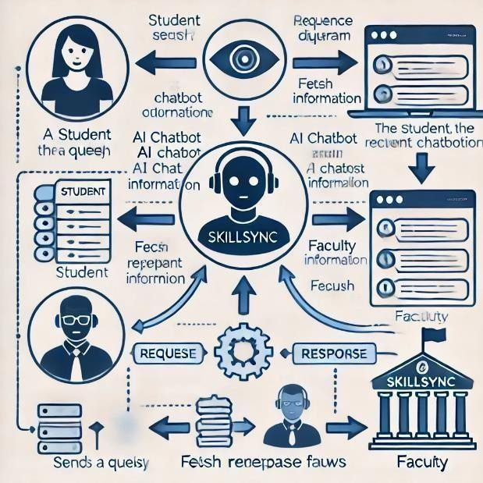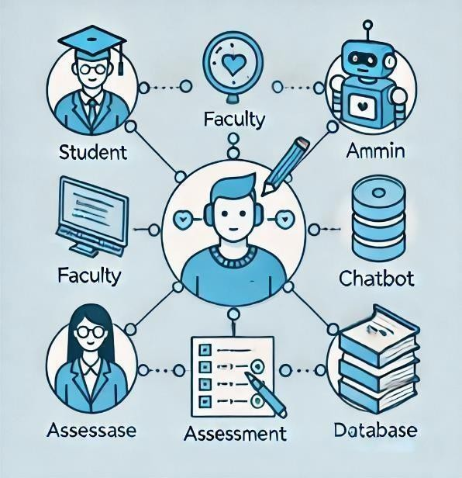

Fig 3.5(a) : Sequence Diagram Fig 3.5(b): Class Diagram

# CHAPTER-IV

## IMPLEMENTATION & FEATURES

The SkillSync platform integrates Conversational AI, adaptive learning, and real-time analytics to create an interactive and personalized learning experience. The implementation involves training AI models, developing user-friendly interfaces, and integrating backend technologies to ensure seamless operation. This chapter covers the core features and implementation details of SkillSync, including AI model training, student-teacher interaction, personalized learning paths, dashboard analytics, and real-time assessment mechanisms.

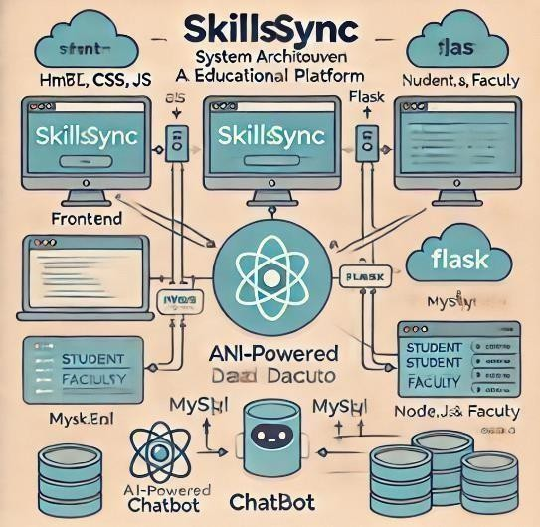

###### CONVERSATIONAL AI MODEL TRAINING

AI-powered chatbots are the foundation of SkillSync, enabling real-time interaction between students and the virtual tutor. The AI is trained using Natural Language Processing (NLP) and deep learning models to understand student queries, provide relevant responses, and adapt to different learning styles. The training process involves:

**Dataset Preparation**: Collecting educational datasets covering subjects like Mathematics, Science, and Language.

**Preprocessing & Tokenization:** Cleaning data and breaking text into meaningful components for AI interpretation.

**Model Training:** Using transformer-based models (GPT, BERT) to improve AI’s ability to generate accurate answers.

**Fine-tuning:** Adapting the chatbot based on real student interactions to refine accuracy and engagement.

**Testing & Optimization:** Measuring chatbot performance based on response accuracy, latency, and student feedback.

###### STUDENT-TEACHER INTERACTION MODULE

SkillSync bridges the communication gap between students and teachers by integrating an AI- assisted Student-Teacher Interaction Module. This feature allows students to receive instant AI responses, while teachers can monitor AI-generated insights and intervene when necessary.

Key Features of the Student-Teacher Interaction Module

AI-Powered Query Resolution: Students ask academic questions, and the AI provides instant explanations.

Teacher Review Mechanism: Teachers can review common student queries and provide manual feedback where AI assistance is insufficient.

Live AI-Assisted Doubt Sessions: Teachers conduct live sessions, where AI assists by automatically categorizing and answering repetitive queries.

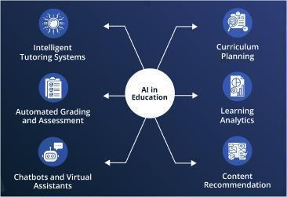

###### PERSONALIZED LEARNING PATHS

One of the key implementations in SkillSync is Personalized Learning Paths, where AI dynamically adjusts content recommendations based on student progress.

How AI Creates Personalized Learning Paths

1. **Student Assessment:** AI analyzes test scores, past interactions, and subject preferences.
2. **Adaptive Content Delivery:** AI suggests customized study materials, such as video lessons, quizzes, and exercises.
3. **Continuous Performance Tracking:** AI monitors improvement and adjusts the learning path accordingly

.

1. **Goal-Based Learning:** Students can set goals, and AI provides structured study plans to achieve them.

###### DASHBOARD AND ANALYTICS INTEGRATION

The Dashboard and Analytics Integration in SkillSync plays a crucial role in tracking student performance, monitoring engagement levels, and generating insights for teachers. This AI- powered dashboard allows educators to identify struggling students early, recommend personalized learning strategies, and optimize teaching methods based on data-driven decisions. The dashboard aggregates real-time AI analytics to help both students and teachers improve the learning experience.

Student Performance Analytics – AI tracks individual student progress, analyzing quiz scores, assignment submissions, and subject-wise strengths and weaknesses. The data is represented through interactive graphs, heat maps, and reports to help teachers understand learning trends.

Engagement Metrics – This section monitors student activity within the SkillSync platform, tracking time spent on lessons, participation in AI-assisted discussions, and responsiveness to adaptive learning materials. Engagement levels help educators assess how involved students are in their learning process.

AI-Generated Recommendations & Alerts – The AI system analyzes past learning patterns and suggests personalized study plans, topic revisions, and additional practice exercises. It also generates alerts for students who need intervention, helping teachers provide timely support before academic struggles become significant.

Predictive Analytics for Future Performance – AI uses historical data to predict a student’s future performance. If a student is consistently weak in a subject, the dashboard provides targeted improvement plans to prevent falling behind.

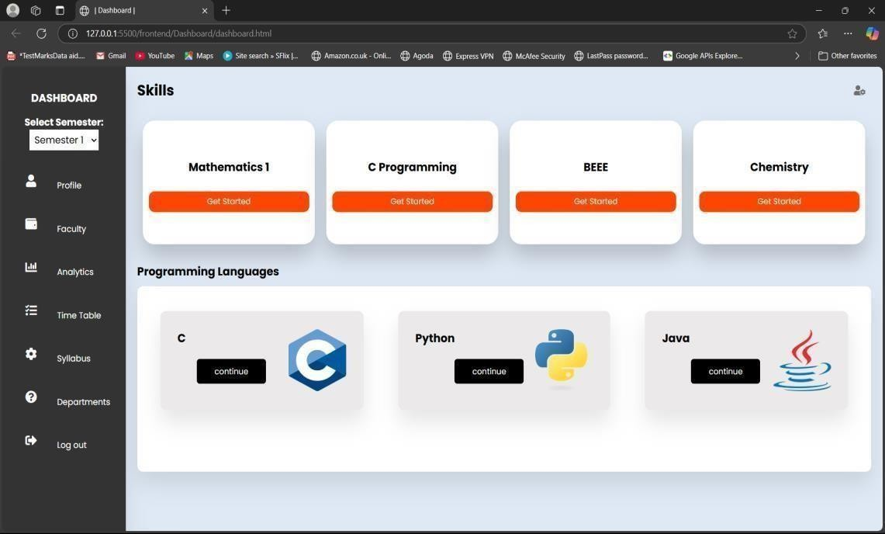

SkillSync leverages data analytics to provide valuable insights into student performance and learning trends. Educators can access detailed reports and dashboards that highlight areas of improvement, track progress, and identify patterns in student behavior. These insights enable educators to make informed decisions and tailor their teaching strategies to better meet the needs of their students.

# CHAPTER-V

### TESTING AND PERFORMANCE EVALUATION

###### TEST CASES AND METHODOLOGIES

The SkillSync platform undergoes rigorous testing and performance evaluation to ensure accuracy, efficiency, and scalability. AI-powered educational platforms must provide fast, reliable, and precise responses to student queries while maintaining high engagement and personalized learning paths. This chapter outlines the testing methodologies, AI performance metrics, user feedback analysis, and continuous improvements implemented in SkillSync.

###### TEST CASES AND METHODOLOGIES

**Unit Testing** – Individual components, such as Conversational AI, NLP models, and analytics dashboard, are tested separately.

**Integration Testing** – Checks how different modules (chatbot, analytics, and assessments) interact within the platform.

**User Acceptance Testing (UAT)** – Real students and teachers use SkillSync, providing feedback on usability, response accuracy, and overall learning experience.

**Load Testing** – Measures system performance under high user traffic to ensure SkillSync remains fast and responsive.

**Security Testing** – Validates data encryption, user authentication, and role-based access controls to prevent unauthorized access.

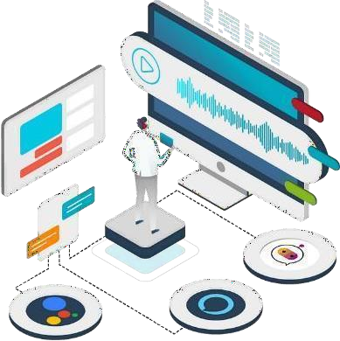

SkillSync is evaluated for response accuracy and speed to ensure it provides quick and reliable answers. AI-generated responses are compared with expert-reviewed answers, ensuring at least 90% accuracy. The platform’s response time is tested under different conditions, with a goal of less than 500ms latency, ensuring real-time interaction. Additionally, AI adapts learning paths dynamically, optimizing content delivery based on student performance trends.

###### ACCURACY AND RESPONSE TIME ANALYSIS

SkillSync is evaluated for response accuracy and speed to ensure it provides quick and reliable answers. AI-generated responses are compared with expert-reviewed answers, ensuring at least 90% accuracy. The platform’s response time is tested under different conditions, with a goal of less than 500ms latency, ensuring real-time interaction. Additionally, AI adapts learning paths dynamically, optimizing content delivery based on student performance trends.

SkillSync’s AI must respond quickly and accurately to ensure an effective learning experience. The system is tested for:

* **Response Accuracy** – AI-generated answers are compared with expert-verified responses to measure precision and relevance.
* **Latency Testing** – Measures how quickly the AI chatbot can process and return responses.
* **Adaptive Learning Speed** – Evaluates how quickly SkillSync adjusts learning paths based on student progress.



Fig 5.2.1 : Accuracy and Response-Time

###### USER FEEDBACK AND ADAPTATIONS

User feedback plays a crucial role in SkillSync’s improvement. Students rate AI- generated responses, while teachers review AI recommendations to enhance accuracy. AI continuously updates based on student interactions, refining its knowledge base and response logic. Common feedback areas include answer accuracy, clarity, and engagement levels, allowing AI to improve weekly through reinforcement learning.

User feedback is critical for improving SkillSync’s AI-driven learning model. The platform gathers feedback through:

1. Student Ratings: After AI interactions, students rate the chatbot's accuracy and helpfulness.
2. Teacher Insights: Educators review AI-generated learning paths and suggest improvements.
3. AI Feedback Loop: The system continuously updates based on real-world interactions and student engagement data.

By analyzing feedback, SkillSync’s AI model is refined weekly, improving answer precision, adaptive learning, and student engagement strategies

To further enhance student engagement, SkillSync incorporates gamification elements into its learning activities. By introducing challenges, rewards, and leaderboards, the platform creates a fun and competitive environment that motivates students to participate actively. Gamification not only makes learning enjoyable but also encourages students to set goals and strive for continuous improvement.

SkillSync is committed to inclusivity and accessibility. The platform offers specialized support for students with learning disabilities and special educational needs. Through adaptive learning techniques and personalized resources, SkillSync ensures that all students, regardless of their abilities, can benefit from the platform and achieve their academic potential.



SkillSync also provides professional development resources for educators. Teachers can access training modules, workshops, and webinars that help them understand and utilize the platform effectively. By equipping educators with the necessary skills and knowledge, SkillSync empowers them to create a more engaging and supportive learning environment for their students.

Recognizing the importance of parental involvement in a child's education, SkillSync includes features that allow parents to monitor their child's progress and participate in their learning journey. Parents can receive updates, access performance reports, and communicate with educators through the platform. This collaborative approach fosters a strong support system for students and enhances their overall learning experience.

SkillSync is designed to be scalable and flexible, accommodating the needs of both small educational institutions and large organizations. The platform can handle a growing number of users and adapt to various educational contexts, making it suitable for diverse learning environments. This scalability ensures that SkillSync can continue to support students as the demand for e-learning solutions increases.

###### AI MODEL FINE-TUNING AND UPDATES

SkillSync’s AI undergoes continuous fine-tuning to enhance accuracy and adaptability. AI models are retrained weekly, refining chatbot responses based on real- world interactions. The system integrates new academic resources, optimizes response speed, and expands multilingual support. Teachers and AI engineers collaborate to correct errors, ensuring AI evolves dynamically to meet student needs.

AI models require continuous fine-tuning to adapt to new educational challenges. SkillSync’s AI improvement strategy includes:

**Weekly Model Retraining:** AI refines responses based on user interactions.

**Error Correction Mechanism**: If a chatbot provides incorrect answers, teachers flag them, and AI improves through reinforcement learning.

**Expanded Knowledge Base:** The AI system integrates new textbooks, research materials, and subject updates.

**Multilingual Support**: AI is trained to support multiple languages for broader accessibility.

By continuously refining AI algorithms, response logic, and student engagement strategies, SkillSync ensures high adaptability and effectiveness in education.

SkillSync prioritizes the security and privacy of its users. The platform employs robust encryption and data protection measures to safeguard student information and ensure compliance with privacy regulations. By maintaining high standards of security, SkillSync builds trust with its users and provides a safe learning environment.

SkillSync is dedicated to continuous innovation and improvement. The platform regularly updates its features and incorporates the latest advancements in AI and educational technology. By staying at the forefront of innovation, SkillSync ensures that it remains a cutting-edge solution that meets the evolving needs of students and educators.

# CHAPTER-VI

### RESULTS AND DISCUSSION

###### 1.COMPARATIVE STUDY WITH TRADITIONAL E-LEARNING PLATFORMS:

1. **Introduction**

E-learning has revolutionized the education industry, offering flexible and cost-effective learning solutions. Traditional e-learning platforms have played a significant role in this transformation. This study aims to compare various traditional e-learning platforms, analyzing their effectiveness, features, and limitations.

1. **Definition and Scope** Traditional e-learning platforms refer to online education systems that provide structured courses, video lectures, assignments, and assessments. These platforms include Learning Management Systems (LMS) like Moodle, Blackboard, and Coursera. The study focuses on comparing usability, content quality, learner engagement, and accessibility.
2. **Features of Traditional E-Learning Platforms**

**Structured Learning Paths**: Course modules follow a set sequence with assessments at regular intervals.

**Multimedia Content**: Integration of videos, quizzes, and PDFs for better understanding. **Assessment Mechanisms**: Tests, assignments, and grading systems ensure learning effectiveness.

**Instructor-Led or Self-Paced Learning**: Platforms offer instructor-guided as well as self- paced learning options.

**Collaboration Tools**: Discussion forums, peer reviews, and virtual classrooms enhance interaction.

1. **Comparative Parameters**

|  |  |  |  |
| --- | --- | --- | --- |
| **Parameter** | **Moodle** | **Blackboard** | **Coursera** |
| Usability | User-friendly | Moderate | High |
| Content Quality | High | High | Very High |
| Engagement & Interactivity | Moderate | High | Very High |
| Cost & Accessibility | Free/Open Source | Paid | Freemium |
| Technological Integration | Basic AI | Moderate AI | Advanced AI |

1. **Advantages of Traditional E-Learning Platforms**

**Flexibility**: Allows learners to access content anytime and anywhere.

**Scalability**: Can accommodate a large number of users.

**Cost-Effective**: Reduces expenses compared to in-person training.

**Trackable Progress**: Learners and instructors can monitor learning progress through analytics.

1. **Limitations of Traditional E-Learning Platforms:**

**Lack of Personalization**: Often follows a one-size-fits-all approach.

**Limited Engagement**: Absence of direct interaction with instructors and peers.

**Technical Challenges**: Connectivity issues and software compatibility concerns.

**Self-Motivation Requirement**: Learners need discipline to complete courses without direct supervision.

###### STUDENT ENGAGEMENT AND LEARNING OUTCOMES:

1. **Introduction**

Student engagement and learning outcomes are crucial factors in evaluating the effectiveness of e-learning platforms. Engagement refers to students' involvement, interaction, and participation in the learning process, while learning outcomes measure their knowledge retention, skill acquisition, and overall academic success.

1. **Comparative Analysis: Traditional vs. E-Learning Platforms**

|  |  |  |
| --- | --- | --- |
| **Aspect** | **Traditional Learning** | **E-Learning Platforms** |
| **Engagement**  **Mode** | Face-to-face interaction with  teachers and peers | Interactive multimedia, gamification, and  virtual classrooms |
| **Flexibility** | Fixed schedule and location | Learn anytime, anywhere with self-paced  modules |

|  |  |  |
| --- | --- | --- |
| **Aspect** | **Traditional Learning** | **E-Learning Platforms** |
| **Personalization** | Standardized curriculum for all  students | AI-driven personalized learning paths |
| **Collaboration** | In-class discussions and group  projects | Online forums, peer discussions, and  virtual group activities |
| **Content Delivery** | Lectures, textbooks, and  printed materials | Video tutorials, simulations, and  interactive exercises |
| **Instructor**  **Feedback** | Direct feedback during class | AI-generated instant feedback and peer  reviews |

1. **Student Engagement Strategies in E-Learning**

E-learning platforms enhance student engagement through:

* + **Gamification**: Points, badges, leaderboards, and rewards
  + **Interactive Content**: Quizzes, simulations, and virtual labs.
  + **Discussion Forums**: Collaborative learning via chat, Q&A, and peer interactions.
  + **Live Sessions**: Webinars, live Q&A, and video conferencing with instructors.
    - **AI-Driven Recommendations**: Personalized learning paths based on performance and interests.

1. **Learning Outcomes: Measuring Effectiveness**

E-learning platforms use **analytics and performance tracking** to measure learning outcomes. Key indicators include:

* + **Completion Rates**: Percentage of students who complete a course/module.
  + **Assessment Scores**: Improvement in quiz/exam results.
  + **Retention Rates**: How well students remember and apply knowledge.
    - **User Engagement Metrics**: Time spent on platform, active participation, and interaction with content.

###### TEACHER EFFICIENCY AND INTERACTION ANALYSIS:

1. **Introduction**

Teacher efficiency and interaction play a crucial role in determining the effectiveness of both traditional and e-learning platforms. Efficiency refers to how well educators can deliver content, manage student progress, and provide feedback, while interaction measures the level of engagement between teachers and students. The shift from traditional classrooms to digital learning has transformed how educators teach, assess, and support students.

1. **Comparative Analysis: Teacher Efficiency & Interaction in Traditional vs. E-Learning Platforms**

|  |  |  |
| --- | --- | --- |
| **Aspect** | **Traditional Learning** | **E-Learning Platforms** |
| **Teaching Methods** | Lectures, textbooks,  classroom activities | Pre-recorded videos, live sessions,  interactive modules |
| **Student Interaction** | Face-to-face discussions,  Q&A sessions | Live chats, discussion forums, AI-driven  chatbots |
| **Feedback**  **Mechanism** | In-person, periodic  assessments | Instant feedback through quizzes, AI  analytics, and automated grading |
| **Time Efficiency** | Fixed class hours, limited  student reach | Scalable teaching with recorded lectures  and online materials |
| **Classroom**  **Management** | Direct supervision,  discipline enforcement | LMS-based tracking, attendance  monitoring, and AI alerts |
| **Personalization** | Generalized teaching for all  students | Adaptive learning paths based on student  performance |
| **Assessment**  **Methods** | Handwritten exams,  personal feedback | AI-driven assessments, real-time analytics,  and peer reviews |

1. **Teacher Efficiency in E-Learning**

E-learning platforms enhance teacher efficiency by:

* + **Automating Administrative Tasks**: Attendance tracking, grading, and report generation.
  + **Content Reusability**: Pre-recorded lectures can be used multiple times, saving teaching effort.
  + **AI & Data Analytics**: Provides insights into student progress and performance, allowing teachers to focus on struggling students.
  + **Scalability**: A single course can reach thousands of students worldwide.

1. **Teacher-Student Interaction in E-Learning**
   * **Synchronous Interaction**: Live video sessions, real-time discussions, webinars.
   * **Asynchronous Interaction**: Discussion forums, recorded lectures, email support.
   * **AI-Driven Assistance**: Chatbots and virtual assistants to provide instant responses.
   * **Collaborative Tools**: Online whiteboards, group projects, and peer review mechanisms.
2. **Diagram: Teacher Interaction in E-Learning vs. Traditional Learning**

**Traditional Teaching Interaction Flow**

Teacher → Student (In-class Discussion) → Paper-based Feedback

**E-Learning Teaching Interaction Flow**

Teacher → Video Lessons / Live Webinar → AI-Powered Feedback → Student Queries (Chat, Forum, Email)

1. **Conclusion**

E-learning platforms improve teacher efficiency through automation, scalability, and AI- powered insights. However, they reduce direct personal interaction, which may impact student motivation. A **blended approach** combining real-time teacher interaction with digital tools can maximize both efficiency and engagement.

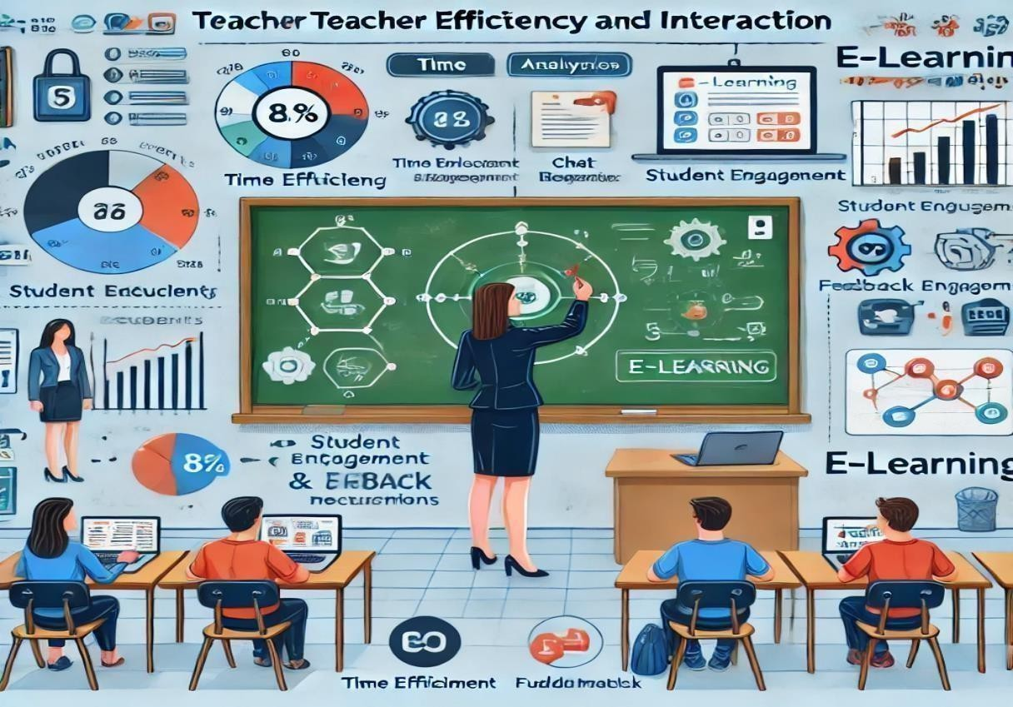

###### SCALABILITY AND FUTURE ENHANCEMENTS:

1. **Introduction**

Scalability is a crucial factor in e-learning platforms, ensuring that they can accommodate growing numbers of users while maintaining performance and efficiency. Future enhancements focus on improving technology, personalization, and accessibility to create a seamless learning experience.

1. **Scalability in E-Learning Platforms**

Scalability refers to an e-learning platform’s ability to handle increased users, content, and interactions without compromising performance. Key factors that contribute to scalability include:

* 1. **Cloud-Based Infrastructure**
     + Supports high traffic and storage requirements.
     + Provides seamless access across different devices and locations.
  2. **AI and Machine Learning**
     + Enables adaptive learning paths based on student performance.
     + Automates content recommendations and personalized assessments.
  3. **Content Delivery Networks (CDNs)**
     + Ensures fast loading times for video lectures and interactive content.
     + Reduces latency for users across different geographical locations.
  4. **Load Balancing and Auto-Scaling**
     + Distributes traffic efficiently to avoid server overload.
     + Automatically adjusts resources based on demand.

1. **Future Enhancements in E-Learning**

To improve efficiency and engagement, future e-learning platforms will incorporate:

* 1. **Immersive Technologies (AR & VR)**
     + Virtual classrooms for interactive, hands-on learning.
     + Augmented reality for real-time simulations in subjects like science and engineering.
  2. **AI-Driven Personalization**
     + Advanced chatbots for instant query resolution.
     + AI-based tutors that adapt to student learning styles.
  3. **Blockchain for Secure Certification**
     + Verifiable digital certificates to prevent credential fraud.
     + Transparent record-keeping for student achievements.
  4. **Gamification & Social Learning**
     + AI-driven game-based learning models to improve engagement.
     + Integration with social platforms for peer-to-peer learning and collaboration.
  5. **Voice & Gesture-Based Learning**
     + Hands-free learning through voice commands and AI assistants.
     + Gesture recognition for interactive e-learning experiences.

###### CONCLUSION AND FUTURE SCOPE

* + 1. **SUMMARY OF FINDINGS**:
       1. **Introduction**

The comparative study between traditional and e-learning platforms highlights key aspects of student engagement, teacher efficiency, scalability, and future enhancements. The findings provide insights into how digital learning has transformed education and what improvements can be made for better outcomes.

* + - 1. **Key Findings**

1. **Student Engagement & Learning Outcomes**
   * **Traditional Learning**: Provides direct face-to-face engagement but lacks flexibility.
   * **E-Learning**: Enhances engagement through gamification, AI-driven personalization, and interactive content.
   * **Outcome**: E-learning platforms improve retention rates and allow self-paced learning, but may lack personal motivation compared to classroom settings.
2. **Teacher Efficiency & Interaction**
   * **Traditional Learning**: Teachers provide direct supervision and feedback, but have limited scalability.
   * **E-Learning**: Automates grading, provides AI-powered analytics, and allows scalable content delivery.
   * **Outcome**: Digital platforms increase efficiency but may reduce real-time interaction and emotional connection with students.
3. **Scalability & Performance**
   * **Traditional Learning**: Limited by physical space, resources, and instructor availability.
   * **E-Learning**: Cloud-based platforms, AI-driven analytics, and automation make scaling easier.
   * **Outcome**: Digital education can accommodate a global audience with minimal infrastructure costs.
4. **Future Enhancements**
   * AI and machine learning will drive personalized education experiences.
   * AR/VR integration will make learning more interactive and practical.
   * Blockchain will enhance security in certification and academic records.
   * Social learning features will increase collaboration among students.
     + 1. **Conclusion**

The study concludes that e-learning platforms offer **higher accessibility, efficiency, and scalability**, but traditional learning still provides **stronger personal interaction and discipline**. A **hybrid learning model**—combining the benefits of both—could be the most effective approach for future education systems.

###### LIMITATIONS OF CURRENT SYSTEM:

1. **Introduction**

While e-learning platforms offer flexibility, scalability, and enhanced engagement, they also come with certain limitations. These challenges impact the effectiveness of digital learning and highlight areas that need improvement for better student outcomes.

1. **Key Limitations of the Current E-Learning System**
   1. **Lack of Personal Interaction**

Limited real-time engagement between students and teachers.

* + - Absence of in-person motivation, leading to lower accountability.
    - Difficulty in assessing student emotions and understanding through body language.
  1. **Digital Divide & Accessibility Issues**
     + Requires stable internet and digital devices, which are not available to all students.
     + Technical issues such as connectivity problems and platform downtimes disrupt learning

Not all students have the necessary digital literacy skills to navigate e-learning tools.

* 1. **Reduced Engagement & Motivation**
     + Self-paced learning can lead to procrastination and lack of discipline.
     + The absence of a structured classroom environment can reduce motivation.
     + Over-reliance on recorded content may lead to passive learning.
  2. **Assessment & Evaluation Challenges**
     + Increased chances of cheating in online exams due to lack of supervision.
     + AI-based assessments may not accurately measure practical skills and critical thinking.
     + Limited hands-on practice for subjects that require physical engagement (e.g., lab-based courses).
  3. **Standardization Issues**
     + Difficulty in creating a uniform curriculum that caters to different learning needs.
     + Content may not always align with accreditation standards or industry requirements.
     + Variation in teaching quality due to differences in instructor expertise and technology adoption.
  4. **Security & Privacy Concerns**
     + Risk of data breaches and hacking of student records.
     + Lack of clear regulations on data privacy for online learners.
     + Potential misuse of AI-driven tracking and monitoring tools.

1. **Diagram: Limitations of E-Learning Systems:**

**Digital Divide →Low Engagement →Assessment Issues →Security Concerns → Standardization Problems**

1. **Conclusion**

Although e-learning has transformed education, it still faces limitations in terms of personal interaction, accessibility, motivation, assessment reliability, and security.

Addressing these challenges through **hybrid learning models, improved AI tools, better regulations, and enhanced digital accessibility** can help make online education more effective and inclusive.

###### POTENTIAL IMPROVEMENTS AND ENHANCEMENT

1. **Introduction:**

E-learning has revolutionized education, but there are still areas that need improvement. By integrating advanced technologies and refining existing systems, online learning can become more effective, engaging, and accessible for all users.

1. **Key Potential Improvements and Enhancements:**
   1. **AI-Driven Personalization:**

* Adaptive learning paths based on student performance and preferences.
* AI-powered virtual tutors for real-time assistance.
* Smart content recommendations to enhance knowledge retention.
  1. **Improved Student Engagement Strategies:**
* Gamification: Points, badges, leaderboards, and interactive challenges.
* Immersive Learning: Augmented Reality (AR) and Virtual Reality (VR) for hands-on experiences.
* Social Learning Features: Integration with discussion forums, peer collaboration tools, and mentorship programs.
  1. **Hybrid Learning Models:**
* Combining traditional classroom teaching with online resources for a blended learning experience.
* On-demand recorded lectures along with scheduled live sessions for better flexibility.
* AI-driven analytics to help teachers track student performance in both online and offline settings.
  1. **Enhanced Assessment & Evaluation Techniques:**
     + AI-based proctoring tools to prevent cheating in online exams.
     + Project-based assessments to encourage practical application of knowledge.
     + Blockchain-based certification for secure and verifiable credentials.
  2. **Increased Accessibility & Digital Inclusion:**
     + Development of offline learning modes for students with limited internet access.
     + Voice and gesture-based interfaces for students with disabilities.

Multi-language support and real-time AI-powered translations for global inclusivity.

* 1. **Advanced Security & Privacy Measures:**
     + End-to-end encryption to protect student data.
     + AI-driven cybersecurity algorithms to prevent unauthorized access.
     + Clearer policies on data privacy and user consent for educational platforms.

1. **Diagram: Future Enhancements in E-Learning:**

Potential Improvements Flow

◆·ru AI Personalization → Gamification & AR/VR → Hybrid Learning → Better Assessments

→ Stronger Security → Increased Accessibility

4. **Conclusion:**

To maximize its effectiveness, e-learning must evolve by incorporating AI, gamification, hybrid models, advanced assessments, better security, and enhanced accessibility. These improvements will create a more engaging, personalized, and inclusive learning experience for students worldwide.

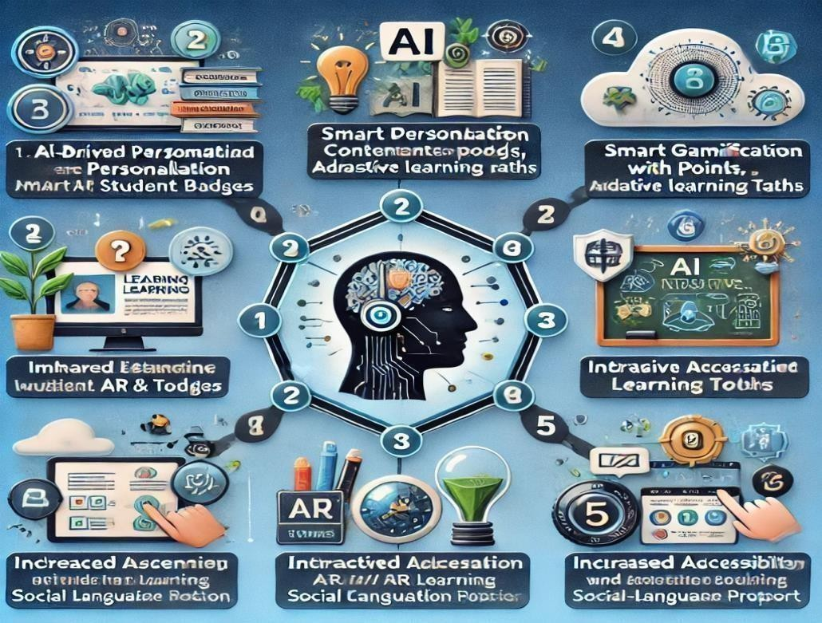

###### APPENDICES:

* + 1. **USER-INTERFACE SCREENSHOTS:**

1. **Introduction:**

User Interface (UI) screenshots provide a **visual representation** of how users interact with an application or platform. They showcase key screens, navigation flow, and design elements, helping in understanding the functionality and usability of the system.

1. **Purpose of UI Screenshots:**

* Demonstrate the **layout and design** of the platform.
* Provide a **step-by-step visual guide** for users.
* Highlight **important features** such as login screens, dashboards, and interactive elements.
* Help in **UI/UX evaluation** by identifying usability improvements.

1. **Common UI Screenshots in E-Learning Platforms:**

|  |  |
| --- | --- |
| **UI Screen Type** | **Description** |
| **Login & Registration** | Displays user authentication, sign-up process, and password  recovery. |
| **Dashboard** | Shows student/teacher dashboard with courses, progress tracking,  and notifications. |
| **Course Content Page** | Displays video lectures, documents, quizzes, and assignments. |
| **Live Class Interface** | Includes video conferencing tools, chat, and interactive whiteboards. |
| **Assessment & Quiz**  **Screen** | Shows test-taking interfaces with multiple-choice questions, timers,  and score tracking. |
| **Discussion Forum** | Interactive platform for student discussions, Q&A, and peer learning. |
| **Profile & Settings** | User profile management, theme selection, and notifications settings. |

###### API DOCUMENTATION:

1. **Introduction:**

API documentation is a detailed **guide that explains how developers can integrate and use an API (Application Programming Interface)** in their applications. It includes information on endpoints, request/response formats, authentication, error handling, and example use cases.

1. **Purpose of API Documentation:**

* Provides **clear instructions** for developers on how to interact with the API.
* Ensures **consistency and standardization** in API usage.
* Helps in **troubleshooting and debugging** API-related issues.
* Improves **developer experience** by offering structured information and examples.

1. **Key Components of API Documentation:**

|  |  |
| --- | --- |
| **Section** | **Description** |
| **Introduction** | Overview of the API, its purpose, and use cases. |
| **Authentication** | Details on API key/token-based authentication (OAuth, JWT,  etc.). |
| **Base URL & Endpoints** | Lists API endpoints with supported HTTP methods (GET, POST,  PUT, DELETE). |
| **Request Parameters** | Defines required and optional parameters for API calls. |
| **Response Format** | Provides sample JSON/XML responses and expected data  structure. |
| **Error Handling** | Lists possible error codes and troubleshooting tips. |
| **Rate Limits & Usage**  **Policies** | Specifies API rate limits and best practices. |
| **Code Examples** | Sample code in various programming languages for easy  integration |

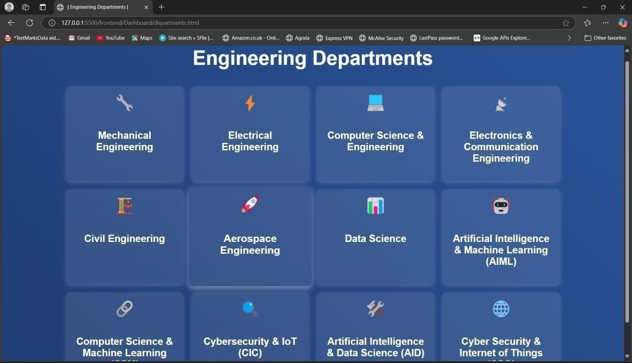

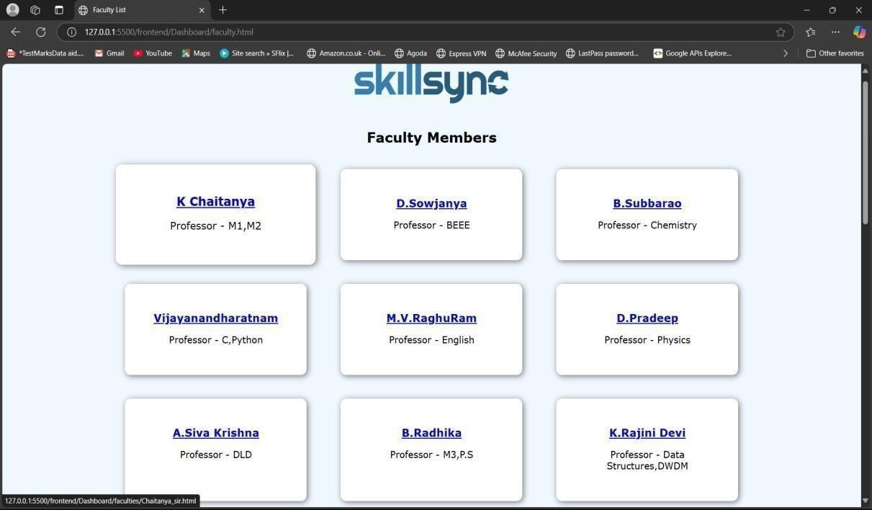

###### CONCLUSION

SkillSync serves as a dynamic solution for bridging the gaps between students and educators by leveraging data-driven insights and real-time engagement. Its comprehensive approach to learning ensures that students receive personalized support through interactive assessments and an intuitive query management system. By facilitating continuous progress tracking, the platform empowers learners to take charge of their academic development.

The analytical dashboard stands at the core of SkillSync, offering faculty members valuable insights into student performance and areas requiring intervention. This data- driven approach enables educators to tailor their teaching strategies effectively, ensuring that no student is left behind. With real-time feedback and performance analytics, the platform fosters a proactive learning environment where both students and teachers can collaborate for academic success.

By integrating personalized testing, real-time interactions, and structured feedback,

SkillSync transforms traditional educational ecosystems into adaptive and student- centric environments. The ability to monitor learning patterns and address queries efficiently enhances the overall learning experience, making education more engaging and effective.

Ultimately, SkillSync is more than just a platform—it is a bridge that connects students and teachers through intelligent analytics and structured communication. By streamlining performance analysis and fostering collaboration, it paves the way for an inclusive, data-driven, and equitable learning environment that benefits all stakeholders in education.

###### BIBLIOGRAPHY

References:

1. Artificial Intelligence in Education:

Luckin, R., et al. (2016). "Intelligence Unleashed: An Argument for AI in Education." Pearson. Woolf, B. P. (2010). "Building Intelligent Interactive Tutors: Student-Centered Strategies for Revolutionizing E-Learning." Morgan Kaufmann.

1. Skill Gap Analysis & Career Guidance:

OECD (2019). "Skills Matter: Additional Results from the Survey of Adult Skills." OECD Publishing.

Borghans, L., & ter Weel, B. (2007). "The Economics of Skill Obsolescence." Research in Labor Economics.

1. Conversational AI & Chatbots in Learning

Hussain, S., Ameri Sianaki, O., & Ababneh, N. (2019). A systematic review of conversational agents in education: Opportunities and challenges. Educational Technology & Society, 22(4), 1-11. Adamopoulou, E., & Moussiades, L. (2020). Chatbots: History, technology, and applications. Machine Learning and Knowledge Extraction, 2(3), 345-369.

1. Assessment & Performance Analytics in Education

Shum, S. B., & Crick, R. D. (2012). Learning analytics for 21st century competencies. Journal of Learning Analytics, 2(1), 1-15. Romero, C., & Ventura, S. (2020). Educational data mining and learning analytics: An updated survey. WIREs Data Mining and Knowledge Discovery, 10(3), e1355.

Web[site links refered:](https://platform.openai.com/docs/overview)

**h**[**ttps://platform.openai.com/docs/ov**](https://dashboard.tawk.to/login)**erview https://dashboard.tawk.to/login**

### APPENDIX

#### Conference Presentation Certificate

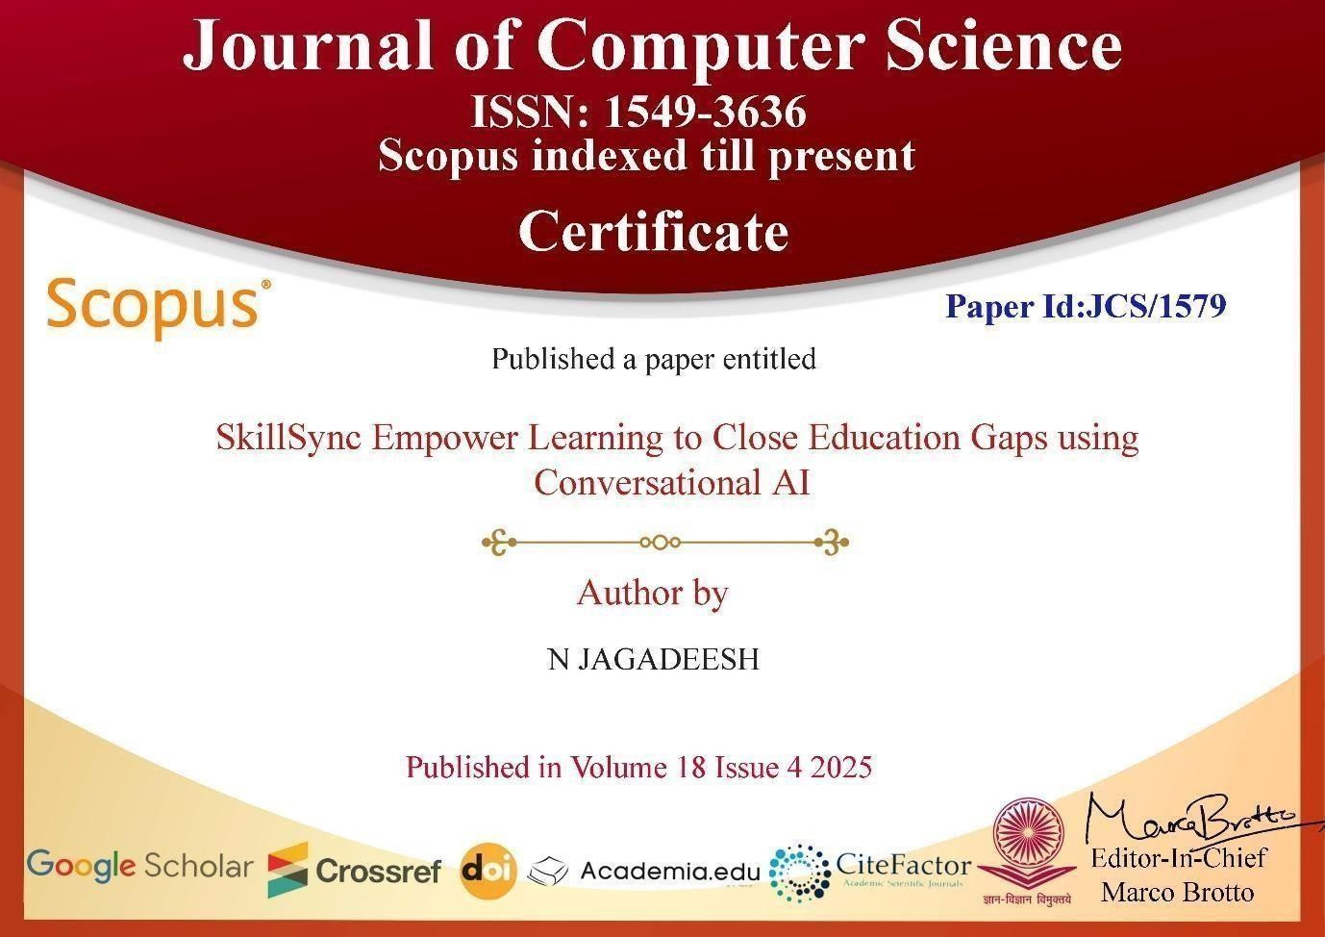

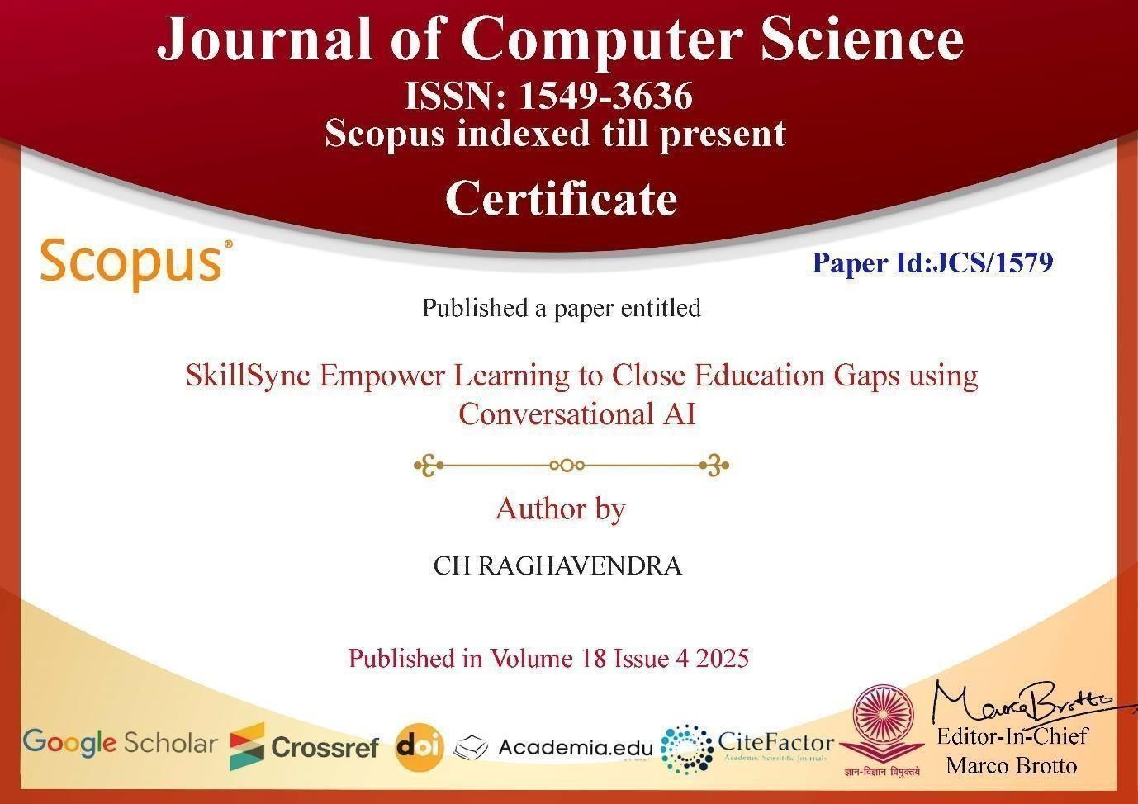

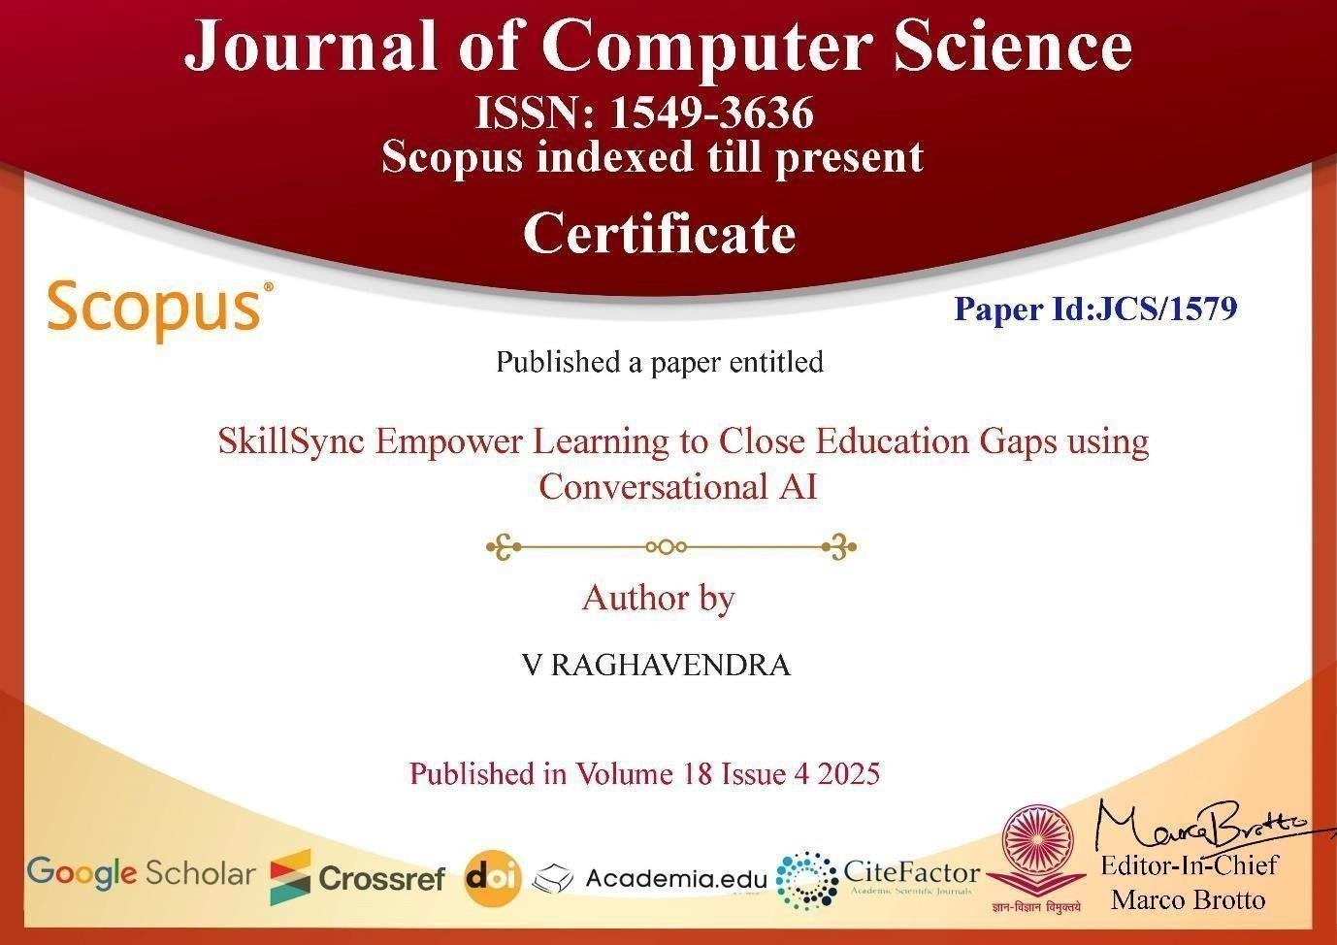

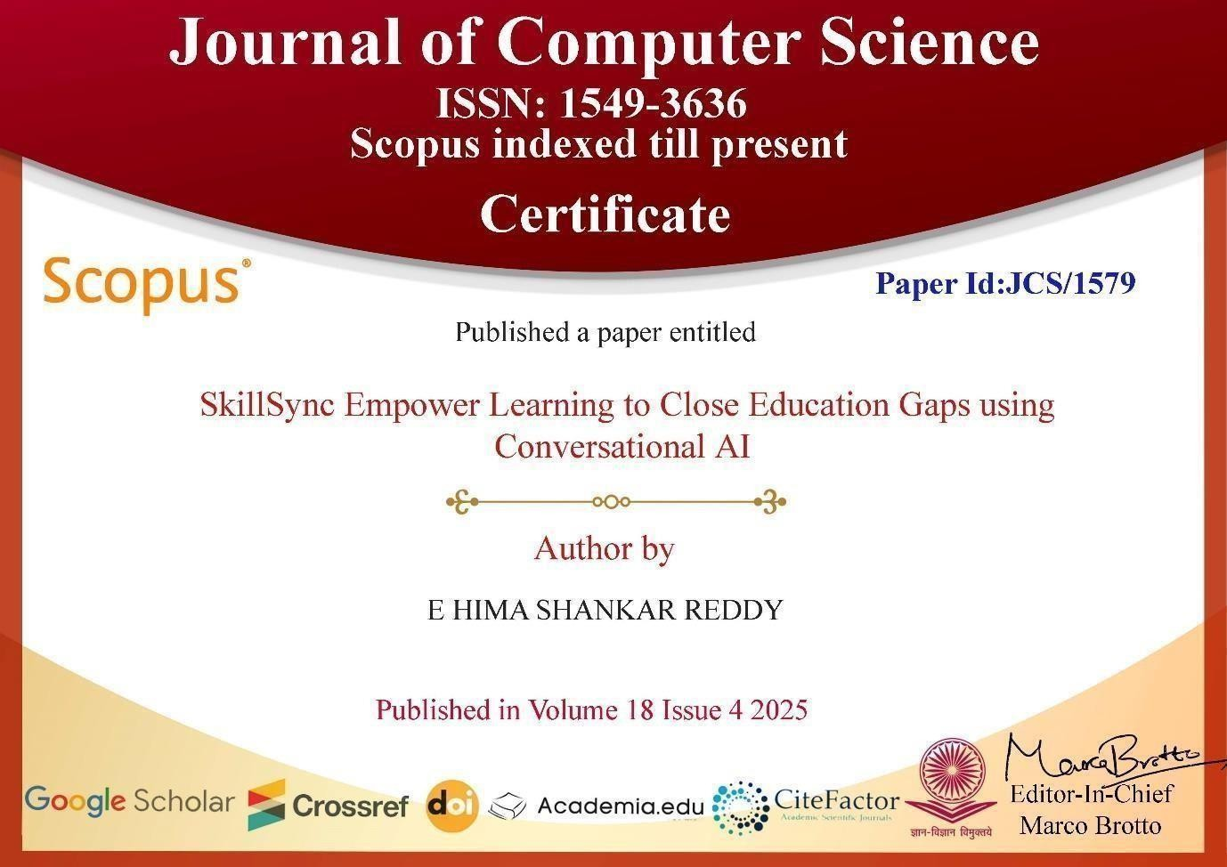

##### SkillSync Empower Learning to Close Education Gaps using Conversational AI

T SUDHIR, N JAGADEESH, CH RAGHAVENDRA, V RAGHAVENDRA, E HIMA SHANKAR REDDY

Department of Artificial Intelligence & Data Science, Vasireddy Venkatadri Institute of Technology, Andhra Pradesh, India

##### ABSTRACT

Fostering equitable and successful learning in contemporary educational ecosystems requires closing learning gaps and matching student skills. The cutting-edge platform SkillSync was created to use analytics to eradicate educational inequities. Students can take part in customized assessments,pose inquiries, and communicate with instructors in real time via its centralized system. An easy-to- use dashboard on the platform offers insights into faculty answers and queries, as well as analytical visualizations driven by data modeling. Furthermore, student performance is assessed via the integrated testing module, and the dashboard shows the results to provide clear feedback and efficiently monitor progress. It helps teachers track student progress and optimize their teaching methods while also simplifying query administration and performance, analysis creating a collaborative and data-driven learning environment.

##### INTRODUCTION

Education is the cornerstone of development, although conventional teaching approaches frequently fall short of meeting pupils' varied learning requirements. Some kids find it difficult to keep up with the fast-paced curriculum,

while others are afraid to raise questions. In contrast, teachers find it difficult to monitor each student's unique learning progress in a classroom. in a classroom. Disengagement, a lack of clarity, and subpar academic achievement are caused by these gaps. By utilizing Conversational AI, a cutting-edge artificial intelligence system that can communicate with students in real time, SkillSync seeks to address these issues. With conversational support driven by AI, SkillSync's main goal is to improve the learning process and help students successfully fill up their knowledge gaps. Both teachers and students stand to gain from the platform's personalized, interactive, and data- driven learning environment. SkillSync will revolutionize the delivery and consumption of education by utilizing cutting-edge AI models, real- time data, and intelligent tutoring.Using AI-powered chatbots to enable real-time student-teacher interactions is one of SkillSync's main objectives. By offering an AI-powered teaching assistant, the SkillSync platform aims to close the learning gap between educators and learnersTeachers can monitor and improve learning outcomes while students receive immediate support thanks to its integration with Conversational AI, Natural Language Processing (NLP), and machine learning, and the effective ones.

##### LITERATURE REVIEW

The absence of real-time communication and tools for resolving doubts is one of the main problems with current e-learning platforms. Because the majority of platforms rely on static information and lectures that have already been recorded, students are unable to ask questions right away when they are having trouble understanding a concept. While some systems offer discussion boards, many questions go unanswered and responses are frequently slow. The lack of immediate, tailored feedback deters active participation and can result in annoyance, perplexity, and decreased learning effectiveness.

* 1. **Role of AI in Personalized Education**

Areca nut Disease Detection Using CNN and SVM Education is undergoing a transformation thanks to artificial intelligence (AI), which makes learning more flexible, interactive, and personalized. AI-driven systems are able to assess learning patterns, evaluate individual student performance, and suggest personalized study materials based on real-time data, in contrast to traditional educational models that employ a one-size- fits-all methodology. This guarantees that every student gets individualized help, which raises engagement, improves retention, and boosts academic achievement.By automating evaluations and feedback systems, AI also improves learning. Due to the delayed feedback provided by traditional testing techniques like quizzes and exams, students find it challenging to fix errors right away.

Students who take AI-powered tests get immediate performance feedback and detailed explanations for any incorrect answers.

* 1. **Conversational AI for Student Engagement**

Maintaining students' active participation throughout the learning process is one of the most difficult tasks in education. Conventional approaches, whether online or in a classroom, frequently lack interaction, which lowers engagement and impairs memoryConversational AI's capacity to gamify the educational process is yet another significant benefit. AI-powered systems engage students to participate more often by integrating interactive challenges, quizzes, and prizes. By transforming studying into a pleasurable activity rather than a chore, gamification has been shown to boost retention rates and enhance student performance. Additionally, conversational AI offers real-time adaptive feedback, guaranteeing that students get prompt explanations for their errors.

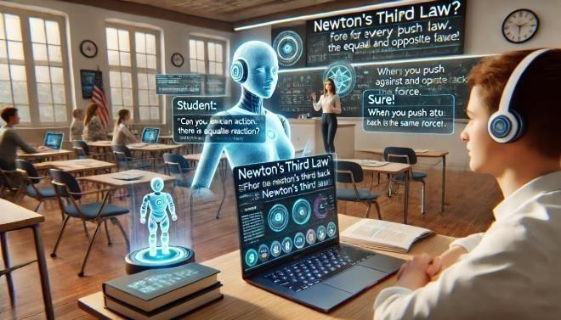

**Fig: Conversational Ai for Student Engage**

By offering an AI-powered teaching assistant, the SkillSync platform aims to close the learning gap between educators and learners.

##### PROPOSED SYSTEM

SkillSync's architecture is made to allow for smooth communication between students and AI-powered learning modules while giving teachers access to real-time data. The conversational AI chatbot, analytics dashboard, adaptive learning engine, and assessment management module are some of the system's many parts. Enhancing individualized learning experiences and raising student engagement requires each of these elements. Through the use of natural language processing (NLP) techniques, the platform's backend is designed to manage a large volume of inquiries while guaranteeing prompt and precise results.

* 1. **Overview of skillsync platform**

The multi-layered AI-driven learning system that is the SkillSync platform is intended to offer real-time student support, individualized instruction, and teacher- assisted monitoring. Together with integrated analytics for performance monitoring, the architecture guarantees smooth communication between students and AI modules. The platform uses cloud- based infrastructure, adaptive learning algorithms, and natural language processing (NLP) to help close the educational gap between teachers and students. Students may ask questions, get immediate answers, and receive AI-driven learning recommendations using SkillSync's Conversational AI Chatbot. In order to provide dynamic content adaptations based on individual learning

needs, the Adaptive Learning Engine continuously tracks student progress. The Analytics Dashboard also gives teachers useful reports that point out important areas where students might need more help.

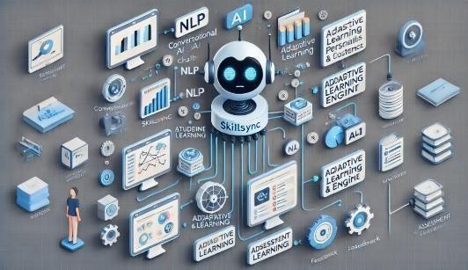

**Fig : AI System**

* 1. **Artificial intelligence**

The goal of the Conversational AI Chatbot is to relieve professors of some of their workload while simultaneously offering students immediate academic assistance. Three primary AI models underpin the chatbot's operation:

The Natural Language Processing (NLP) model comprehends student inquiries and interprets text- based exchanges.

Procedures of the AI Chatbot

1. A student asks a question, such as "Explain Newton’s Third Law"
2. The NLP model extracts pertinent keywords after interpreting the query.
3. The optimal response is retrieved from the knowledge database by the machine learning engine.
4. The student is shown the created response.
5. Over time, AI modifies learning preferences and monitors student interactions.
   1. **Frontend and backend Technologies**

The SkillSync platform is developed using a modern tech stack to ensure high-speed performance, scalability, and security.

The system is divided into:

**Frontend Technologies** – Handles user interactions and UI components.

**Backend Technologies** – Manages AI models, databases, and cloud-based processing.

|  |  |
| --- | --- |
| **Component** | **Technology used** |
| Frontend | Html, css, Javascript |
| Backend | Flask |
| Database | MySQL |
| AI Frameworks | OpenAI GPT |

##### IMPLEMENTATION & FEATURES

To offer a personalized and interactive learning experience, the SkillSync platform combines real-time data, adaptive learning, and conversational AI. Training AI models, creating intuitive user interfaces, and integrating backend technologies are all part of the implementation process to guarantee smooth operation. The main functions and implementation specifics of SkillSync are covered in this chapter. These include dashboard analytics, student-teacher interaction, tailored learning paths, AI model training, and real-time evaluation tools.

1. **Conversational AI model training**

Conversational AI is revolutionizing interactions between students and teachers by making learning more efficient, scalable, and personalized. Data collection, model creation,

and iterative enhancements to improve accuracy and engagement are all part of training AI models for these kinds of interactions.An extensive collection of actual or simulated student-teacher conversations is necessary for training an AI model. This data comprises frequently asked questions, answers, comments, and explanations. In the process of gathering such data, ethical questions including consent and data protection are vital. AI models are trained utilizing Natural Language Processing (NLP) approaches, such as transformer- based architectures like GPT and BERT. To make sure the AI can comprehend and provide replies that are similar to those of a human, the training method incorporates both supervised and reinforcement learning.

1. **Student Teacher Interaction module**

By including a Student-Teacher Interaction Module with AI support, SkillSync helps teachers and students communicate more effectively. With this feature, kids may get immediate AI responses, and teachers can keep an eye on the insights produced by AI and take appropriate action.

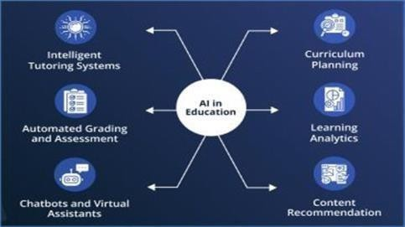

**Fig: Interaction Module**

The Student-Teacher Interaction Module's Principal Elements:

Artificial Intelligence-Powered Query Resolution: When students pose academic queries, the AI instantly responds with answers.

Teachers can evaluate frequently asked questions by students and give manual feedback when AI support isn't enough.

Teachers lead live AI-assisted doubt sessions in which AI helps by automatically classifying and responding to frequently asked questions.

1. **Dashboard and Analysis Integration**

SkillSync's Dashboard and Analytics Integration is essential for tracking student performance, keeping an eye on engagement levels, and producing insights for educators. Using data-driven decision-making, an AI- powered dashboard enables teachers to optimize teaching practices, suggest individualized learning solutions, and spot difficult pupils early. To assist teachers and students in enhancing the educational process, the dashboard compiles real-time AI analytics. AI- powered student performance analytics monitors each student's development by examining test results, completed assignments, and subject-specific strengths and weaknesses. To assist teachers in understanding learning trends, the data is shown using interactive graphs, heat maps, and reports.

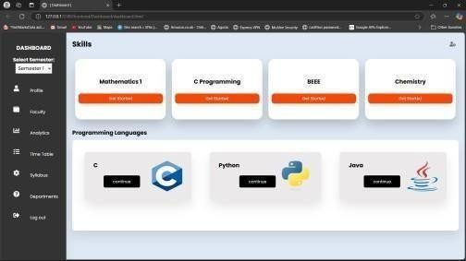

**Fig: Student Dashboard**

##### PERFORMANCE EVALUATION

For a conversational AI-powered student- teacher interaction module to be effective, testing and performance evaluation are

essential. The procedure include evaluating the model's capacity to deliver precise, pertinent, and captivating answers that improve the educational process. Functional testing is a component of the testing step that assesses the AI's fundamental abilities, including comprehending queries, producing pertinent answers, and preserving conversation flow. Furthermore, integration testing guarantees smooth communication with various educational resources and learning management systems. Analyzing the AI's accuracy, responsiveness, flexibility, and user happiness is part of performance evaluation. The model's language performance is measured by metrics like precision, recall, F1-score, and perplexity, and its practical efficacy is evaluated by user feedback and engagement levels.

1. **Test cases and methodologies**

Unit testing involves testing individual parts, such as the analytics dashboard, NLP models, and conversational AI. Integration testing examines how the platform's many modules— such as the chatbot, analytics, and assessments—interact. Real teachers and students utilize SkillSync for User Acceptance Testing (UAT), which yields feedback on the entire learning experience, response accuracy, and usability.

In order to make sure SkillSync stays quick and responsive, load testing evaluates system performance under heavy user traffic.

To prevent unwanted access, security testing verifies role-based access rules, user authentication, and data encryption.

To make sure it delivers prompt and dependable responses, SkillSync is assessed for response accuracy and speed. At least 90% accuracy is ensured by comparing AI-generated solutions with expert-reviewed answers. To ensure real-time interaction, the platform's response time is evaluated in a variety of scenarios with a target latency of less than 500 ms. AI also dynamically modifies learning routes, optimizing the delivery of knowledge according to patterns in student performance.

1. **User Feedback and Adaptations**

User input is essential to the development of SkillSync. While teachers examine AI suggestions to improve accuracy, students score AI-generated responses. AI is constantly improving its knowledge base and reaction logic in response to student interactions. Answer accuracy, clarity, and engagement levels are common feedback areas that enable AI to get better every week through reinforcement learning.

In order to improve SkillSync's AI-driven learning model, user feedback is essential. The platform collects user feedback by:

1. Student Ratings: Following AI exchanges, students assign a score to the chatbot's usefulness and accuracy.
2. Teacher Insights: Teachers examine learning paths produced by AI and recommend enhancements.
3. AI Feedback Loop: Based on data about student involvement and real-world interactions, the system is updated regularly.

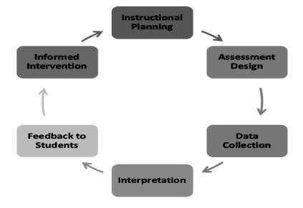

Every week, SkillSync's AI model is improved through feedback analysis, enhancing student engagement tactics, adaptive learning, and answer accuracy.

1. **AI Model fine tuning and updates**

The AI at SkillSync is constantly improved to increase precision and flexibility. Every week, AI models are retrained to improve chatbot responses based on actual encounters. The technology increases multilingual support, optimizes response time, and incorporates new academic materials. In order to guarantee that AI develops

dynamically to satisfy student demands, educators and AI engineers work together to fix mistakes.

AI models must be continuously improved in order to meet emerging educational difficulties. The following are part of SkillSync's AI improvement strategy:

AI improves replies based on user interactions through weekly model retraining.

Error Correction Mechanism: Teachers detect chatbots that give inaccurate responses, and AI becomes better through reinforcement learning. Increased Knowledge Base: New research materials, textbooks, and topic updates are all included by the AI system.

Multilingual Support: For greater accessibility, AI has been trained to support multiple languages.

SkillSync guarantees great flexibility and efficacy in teaching by consistently improving AI algorithms, response logic, and student engagement tactics.

##### IV. CONCLUSION

SkillSync serves as a dynamic solution for bridging the gaps between students and educators by leveraging data-driven insights and real-time engagement. Its comprehensive approach to learning ensures that students receive personalized support through interactive assessments and an intuitive query management system. By facilitating continuous progress tracking, the platform empowers learners to take charge of their academic development.

The analytical dashboard stands at the core of SkillSync, offering faculty members valuable insights into student performance and areas requiring intervention. This data-driven approach enables educators to tailor their teaching strategies effectively, ensuring that no student is left behind. With real-time feedback and performance analytics, the platform fosters a proactive learning environment where both students and teachers can collaborate for academic success.

By integrating personalized testing, real-time interactions, and structured feedback,

SkillSync transforms traditional educational ecosystems into adaptive and student-centric environments. The ability to monitor learning patterns and address queries efficiently enhances the overall learning experience, making education more engaging and effective. Ultimately, SkillSync is more than just a platform—it is a bridge that connects students and teachers through intelligent analytics and structured communication. By streamlining performance analysis and fostering collaboration, it paves the way for an inclusive, data-driven, and equitable learning environment that benefits all stakeholders in education.

##### REFERENCES

1. Artificial Intelligence in Education: Luckin, R., et al. (2016). "Intelligence

Unleashed: An Argument for AI in Education." Pearson.

Woolf, B. P. (2010). "Building Intelligent Interactive Tutors: Student-Centered Strategies for Revolutionizing E-Learning." Morgan Kaufmann.

1. Skill Gap Analysis & Career Guidance: OECD (2019). "Skills Matter: Additional Results from the Survey of Adult Skills." OECD Publishing.

Borghans, L., & ter Weel, B. (2007). "The Economics of Skill Obsolescence." Research in Labor Economics.

1. Conversational AI & Chatbots in Learning Hussain, S., Ameri Sianaki, O., & Ababneh, N. (2019). A systematic review of conversational agents in education: Opportunities and challenges. Educational Technology & Society, 22(4), 1-11.

Adamopoulou, E., & Moussiades, L. (2020). Chatbots: History, technology, and applications. Machine Learning and Knowledge Extraction, 2(3), 345-369.

1. Assessment & Performance Analytics in Education

Shum, S. B., & Crick, R. D. (2012). Learning analytics for 21st century competencies. Journal of Learning Analytics, 2(1), 1-15.

Romero, C., & Ventura, S. (2020). Educational data mining and learning analytics: An updated survey. WIREs Data Mining and Knowledge